FaceTrack:

An Automated Monitoring Attendance System Using Facial Recognition for On Campus Student

Project Documentation Submitted to the Faculty of the School of Computing and Information Technologies

Asia Pacific College

In Partial Fulfillment of the Requirements for

SHS Bootcamp

By

Aragon, Mj

Pinlac, Crate Marshall

Revilla, Ma. Sofia Anne

Ronquillo, Karol Joy

Salamera, John Gabriel

**Table of Contents**

Executive Summary 1

List of Figures 3

Introduction 1

Project Context 2

Statement of the Problem 3

Objectives 3

Significance of the Project 5

Scope and Limitations 7

Review of Related Literature / Systems 8

Technical Background 14

Current System 16

Proposed System 17

Conclusion 21

References 25

Appendices 26

Appendix A: Project Vision 26

Appendix B: Schedule 27

Appendix C: Product Roadmap 28

Appendix D: Users’ Manual 31

Appendix E: Team Meetings 34

Appendix F: Source Code 49

Appendix G: Marketing Plan/Study 50

Appendix H: Use Case Full Description 51

Appendix I: Design Thinking 55

# Executive Summary

The Asia Pacific College (APC) still relies on a manual paper-based attendance system. While this method may seem straightforward, it presents several challenges that hinder efficiency and communication. Valuable class time is wasted during attendance calls, errors in recording can occur, and real-time data on student presence is unavailable. This outdated approach creates an information and security gap between the school admins, parents, security guards and students. Security of the school adhere to safety of those who are inside the school parameter, such as in need of way to locate and navigate certain students throughout the school, whether they have entered onsite or leave the parameter, in this way the safety of the school and the student itself will not be compromised. While for the parents may not receive timely confirmation of their child's arrival, and students experience delays during attendance.

This project proposes a groundbreaking solution: a facial recognition attendance system. High-definition cameras and secure facial recognition software will automatically identify and record student attendance upon arrival. That will eliminate the hassle of manual processes such as attendance calls, ID scanning, or sign-in sheets. The system streamlines the process and minimizes congestion at entry points, allowing students to enter campus seamlessly.

The benefits of this system extend to all members of the APC community. Security guards will gain access to real-time monitoring reports and historical trend analysis. This empowers them to address potential monitoring issues and minimize casualties that compromise the security of the school and the students. Parents will receive instant notifications upon their child's arrival on campus, providing peace of mind and fostering a sense of security. Students will enjoy a hands-free and efficient attendance process, allowing them to focus on their studies from the moment they enter campus.

However, the proposed system is about more than just immediate benefits. It also prioritizes data security and adaptability, which are crucial for the long-term vision. The protection of student data will be enhanced using more advanced encryption algorithms, which assure complete compliance with all relevant privacy provisions. Furthermore, the system's scalability and adaptability will allow it to be seamlessly integrated into future campus security measures in order to further enhance APC community safety. Therefore, APC is making a valuable long-term investment in the facial recognition system for attendance, providing parents with peace of mind and a sense of student safety.

By implementing the project, APC is committed to fostering a more informed, secure, and productive learning environment. This system will not only enhance communication but also foster collaboration between faculty, parents, and students. This collaborative approach will contribute to a more positive and successful learning experience for all students at Asia Pacific College, making them feel more connected and involved in the educational process.

Figure 1: Current System flow (Security Personnel) 17

Figure 2: Current System flow (Parents) 17

Figure 3: Current System of Face Track (Students) 18

Figure 4: Proposed System of Face Track (Parents POV) 20

Figure 5: Proposed System of Face Track (Security Personnel POV) 21

Figure 6: Proposed System of Face Track (Students POV) 22

Figure 7: Gantt Chart 30

Figure 8: Product Roadmap (Security Personnel) 31

Figure 9: Product Roadmap (Student) 31

Figure 10: Product Roadmap (Parents) 32

Figure 11: Hill diagram of Security Personnel, student, parents 32

Figure 12: User Manual (Introduction) 33

Figure 13: User Manual (Logging in) 34

Figure 14: User Manual (Security Personnel) 35

Figure 15: User Manual (Parents) 36

Figure 16: User Manual (Features) 37

Figure 17: User Manual (Data Privacy Notice) 38

Figure 18: Team Meetings (May 8, 2024) 39

Figure 19: Team Meetings (May 9, 2024) 40

Figure 20: Team Meetings (May 13, 2024) 41

Figure 21: Team Meetings (May 14, 2024) 43

Figure 22: Team Meetings (May 20, 2024) 44

Figure 23: Team Meetings (May 21, 2024) 45

Figure 24: Team Meetings (May 28, 2024) 47

Figure 25: Team Meetings (May 30, 2024) with sample of facial recognition system 48

Figure 26: Meeting with IBM Mentor 49

Figure 27: Github Face Track 51

Figure 28: Problem Rundown of Security Personnel, Parents and Students 58

Figure 29: Need Statements (Security Personnel) 59

Figure 30: Need Statements (Parents) 60

Figure 31: Need Statements (Students) 60

Figure 32: The good and bad ideation of Face Track 61

Figure 33: Sketch of Face Track (1) 61

Figure 34: Sketch of Face Track (2) 62

Figure 35: Prioritization Grid (Security Personnel) 63

Figure 36: Scenario Map (Security Personnel) 64

Figure 37: Prioritization Grid (Parents) 64

Figure 38: Scenario Map (Parents) 65

Figure 39: Priotization Grid (Students) 65

Figure 40: Scenario Map (Students) 66

Figure 41: Empathy Map (Security Personnel) 66

Figure 42: Empathy Map (Parents) 67

Figure 43: Empathy Map (Students) 67

Figure 44: Storyboard (Security Personnel) 68

Figure 45: Storyboard (Parents) 69

Figure 46: Storyboard (Student) 69

Figure 47: ERB of Security Personnel 71

Figure 48: ERB of Students 73

Figure 49: ERB of Parents 75

# List of Figures

# Introduction

Monitoring is a crucial part of an educational institution; it is vital in protecting organizations by offering a holistic view of their security landscape. It is a vital tool for monitoring and recording the presence of students on campus. By having an accurate record of students' attendance, educational institutions can ensure that they can maintain a secure and organized environment for both students and staff. Having the capability of tracking and recording the attendance of those who have entered school premises allows schools to catch those intentionally cutting classes, which can serve as a tool for the security personnel members to take a more proactive approach when dealing with such behavior so that they can intervene and address the issue with the student and their parents. It also allows schools to inform the student's parents that their child has arrived safely on campus. Communication between the school and the parent reassures the parents that their child has arrived safely, building trust and security between the school and families.

Many institutions have already taken steps to implement a system for tracking and recording their students' arrival on campus. One popular method is an RFID system, which uses students' IDs and an RFID reader to scan and record their attendance. This process is known for its effectiveness and efficiency. However, Asia Pacific College can take it a step further by leveraging facial recognition technology. This innovative approach eliminates the need for students to physically scan IDs. Instead, they can simply enter campus and be identified by security cameras. This hands-free system not only enhances security but also can efficiently handle surges in student arrivals, mitigating potential bottlenecks and delays. A good example is the LRT or MRT system, which uses the same technology and scenario. With the surges of people exiting the vicinity, huge lines or crowds form because of the system's delays and limitations, such as its ability to handle only one customer at a time. We believe that we can make this process faster and more seamless for the user.

By implementing facial recognition technology, we can streamline the process of recording a student's attendance and arrival on campus. With this technology, students only need to enter the campus and get detected by the camera, making the process completely hands-free. This will not only be an efficient but also a simplified process for students. It will also allow the system to handle a surge of students arriving on campus, mitigating a possible bottleneck. Unlike the existing RFID system, which requires students to scan their IDs physically, our new system eliminates the need for physical scanning, reducing delays and congestion.

## Project Context

This project aims to improve how students are tracked, monitored and communicated within Asia Pacific College (APC). There is no currently a system that allows the security admins to view and attain the attendance and monitor of the students, at present their objective is to ensure that student neither faculty will be checked once entered the school building. While for the attendance monitoring uses manual methods like paper sign-in sheets and manual headcounts, which waste time, lead to mistakes, and don't provide real-time data. This challenges faculty, admins and security to track attendance and identify students physically on campus but skipping classes, at the same time security guards have no assurance that certain students will enter the classes even though they have entered the school building. Parents also lack immediate confirmation of their child's arrival, causing anxiety.

This project solution leverages innovative technology to address these shortcomings. Students will be identified using RFID cards or wearables, while strategically placed readers at entrances and exits will automatically log arrival and departure times. This real-time data empowers security and fosters stronger and secure communication between APC and its community. Parents will receive automated notifications upon their child's arrival, and security personnel can proactively address potential issues with class participation and attendance monitored throughout the day. The system aims to streamline administrative processes, enhance campus safety, and improve student engagement.

## Statement of the Problem

The project aims to address several issues currently experienced in educational institutions regarding student attendance and parental concerns. Specifically, the study will investigate and provide solutions to the following problems:

1. students who arrive on campus but doesn’t go to their classes

2. students who cuts classes

3. Monitoring students entering and exiting the building

4. Worried parents/guardians

## Objectives

This research aims to create a real-time monitoring and communication system that improves overall student well-being and a facial recognition attendance system to enhance the accuracy and efficiency of tracking and recording school students. This system addresses issues such as students being present on campus but not attending classes, cutting classes, and causing parents' concerns regarding their children's attendance and safety. To lessen the worry of parents, the group aims to develop and implement a facial recognition attendance system that ensures highly accurate facial Recognition for Secure Identification, with the system already developed facial recognition system with an accuracy rate of 95%. This will ensure reducing the risk of potential threats. This initial development and testing phase is targeted for completion within six months. Improved Real-Time Communication for Faster Response. Having a system will integrate a notification system with the goal of achieving 100% parent notification upon their child's arrival at school. Students will also receive instant confirmation messages. This real-time communication not only keeps parents informed but also allows security personnel to be alerted to any unusual activity or unauthorized entry. The notification system will be designed to integrate seamlessly with existing security protocols for the fastest possible response times. The deployment of this phase is planned within three months of the development of the facial recognition system. And lastly, Enhanced Security Monitoring and Response. With a  user-friendly dashboard specifically designed for security personnel will be developed. This dashboard will display real-time and comprehensive attendance records, allowing security personnel to locate students efficiently and maintain a clear understanding of who is present on campus at any given time. Easy access to attendance data (with a 90% user-friendliness target) empowers security personnel to respond proactively to potential safety concerns. Data visualization tools will be incorporated to facilitate efficient monitoring of student presence. This phase is planned for launch within three months of implementing the facial recognition and notification systems.

By achieving these specific objectives in a phased approach, this research strives to create a safer learning environment for students. The improved monitoring, communication, and response capabilities provided by the facial recognition attendance system will give both parents and school security greater peace of mind.

## Significance of the Project

The project is a new way to track student attendance on campus. The group proposed automated student attendance system significantly benefits the Asia Pacific College community, faculty, parents, and students. According to Ali et al. (2022), It eliminates human error in attendance records, saving teachers and professors valuable class time. Moreover, Facial recognition will allow them to focus on instruction and identify students physically on campus but not attending classes. Furthermore, this project and research will benefit different target-audiences such as the following:

**Security Personnel.** The proposed facial recognition system significantly bolsters campus security. Real-time attendance data allows security personnel to identify students who are physically on campus but haven't attended classes, potentially revealing security threats or missing individuals. Moreover, by automating attendance recording, security personnel are freed from manual monitoring duties, enabling them to focus on patrolling campus grounds and responding to incidents more effectively. The system can further integrate with existing access control systems, streamlining student verification in restricted areas. This enhances overall security and allows for faster response times in emergencies, as security personnel can quickly identify students who might be missing from class and investigate potential safety concerns.

**Student.** This system prioritizes student safety and convenience. students will benefit from the initiative by providing protection and safety for students who attend on-site, as well as eliminating the potential of the kid having to provide updates or messages to their parents on a daily basis. By using a facial recognition monitoring system, students will not have to go through traditional onsite attendances.

**Parents.** this facial recognition monitoring system provides an application that will benefit not only the student and faculty but also the parents. By acquiring the project, parents will be able to locate or be updated that their child has arrived safely at school, providing reassurance through emails and an update bar that will inform them whether or not their child is onsite.

Overall, the system addresses the limitations of traditional paper-based methods by automating attendance recording, ensuring data accuracy, and providing valuable insights. This can improve efficiency, communication, and student safety, indirectly contributing to achieving Sustainable Development Goal 4: Quality and Secure Education (| Sustainable Development, n.d.).

## Scope and Limitations

This study investigates the application and effectiveness of a facial recognition attendance system within educational institutions. The primary users of the system include faculty members, parents, and students, aiming to enhance the accuracy and efficiency of attendance tracking, provide real-time updates, and ensure safety during emergencies. However, it is essential to address privacy concerns and technical challenges for successful implementation.

Privacy perspective, facial recognition systems pose significant risks, particularly in private of the school setting s where students are often minors. Obtaining genuine consent from students, parents, and teachers is a complex challenge. The data storage and security are also crucial, as these system collect sensitive data. Ensuring secure storage and responsible use is essential to prevent data breaches that could harm students. Moreover, the constant surveillance nature of the system raises privacy concerns.

There are also some technical limitations, such as the need to enhance the accuracy of facial recognition technology in a way resolution of Variations in lighting, facial expressions, obstructions like glasses or masks, and changes in appearance due to aging or hairstyles can reduce the system's effectiveness, leading to misidentifications. Additionally, implementing and maintaining facial recognition systems can be costly, posing challenges for large institutions with many students , faculty and even the admissions.

Despite these limitations, the study aims to offer valuable insights into the advantages and disadvantages of using facial r cognition for attendance tracking. By examining both sides, the research seeks to contribute to improved attendance practices while safeguarding student safety and privacy.

# Review of Related Literature / Systems

This section provides an overview of previous related literature and systems on facial recognition attendance systems. This is to discuss the technology, applications, advantages, accuracy, reliability, security measures. Furthermore, it will delve into the integration of facial recognition technology with educational institutions, highlighting the benefits for students, parents, and faculty members. Additionally, it will explore the programming languages and frameworks commonly used to develop these systems and address the limitations and challenges faced in their implementation. By reviewing existing studies and systems, this section aims to provide a comprehensive background and context for the development and deployment of an advanced facial recognition attendance system.

***Overview of Facial Recognition Attendance Systems***

The implementation of facial recognition technology in educational institutions has demonstrated significant benefits in improving attendance tracking and monitoring. While facial recognition may not achieve the same accuracy levels as fingerprint, iris, or RFID card recognition, its non-contact nature makes it a popular choice for many applications (Nguyen et al., 2021). This advanced technology not only enhances security measures but also simplifies real-time attendance tracking, thereby reducing the administrative workload and minimizing the likelihood of errors. Facial recognition systems are particularly advantageous in large organizations where monitoring the attendance of numerous individuals can be challenging. Moreover, facial recognition technology has become an integral part of daily life, providing substantial convenience. However, this widespread adoption raises concerns about the security and privacy of personal information. The dual nature of facial recognition technology highlights the need for a balanced approach, ensuring both its benefits and the protection of individual privacy (Mingtsung & Cai, 2020).

The integration of facial recognition technology into attendance management systems offers a promising solution to the limitations of traditional methods. By leveraging this advanced technology, we aim to create a system that improves accuracy, efficiency, and security, thereby contributing to a more effective and modern educational environment. The researchers’ study and facial recognition system are designed to harness these benefits while addressing the critical need for privacy protection, ensuring a balanced and responsible approach to technological innovation in education.

***Benefits of Real-Time Attendance Tracking***

Attendance among students is a significant issue widely discussed by teachers in Higher Education Institutions (HEIs) they face today. Some HEIs have implemented compulsory attendance rules, while others have chosen to take a more flexible approach. However, educators in higher education commonly believe that regular attendance can greatly enhance academic achievement. On the other hand, missing class lectures is frequently identified as a factor that can lead to subpar academic results (Ancheta et al., 2021). The adoption of facial recognition systems for attendance tracking presents numerous benefits compared to traditional methods. Schools that have implemented these systems have seen a noticeable decrease in students being late or absent. By tracking attendance in real-time, schools can quickly identify students who are on campus but not in class, helping to tackle truancy more efficiently. Additionally, this technology offers a convenient way for parents to stay informed about their child's attendance, easing their worries and improving student safety.

From the researchers' point of view, the adoption of facial recognition systems for attendance tracking is seen as a solution to overcome the inefficiencies and inaccuracies associated with traditional methods. The researchers have chosen to implement this advanced technology in their project to ensure accurate and efficient attendance management. The system aims to provide real-time tracking, ease parental concerns, and enhance overall student safety. By addressing both the technological and practical aspects of attendance monitoring, the researchers intend to create a more reliable and effective system that supports academic success and fosters a secure educational environment.

***Limitations of Traditional Attendance Methods***

This chapter explores the limitations of traditional university attendance methods and proposes a Student Attendance Management System (SAMS) as a solution. Manual attendance processes, like paper sheets and time clocks, could be more efficient and prone to errors such as buddy punching (Zuanuwar, 2020). SAMS aims to overcome these shortcomings by automating attendance recording, data management, and report generation. Current research highlights the drawbacks of manual attendance systems. Studies by Zuanuwar (2020) demonstrate how buddy punching, where one student signs in for another, can lead to inaccurate attendance data. This inaccuracy can negatively impact efforts to track student engagement and academic performance.

Several existing attendance management systems offer functionalities like those of SAMS. These systems typically record student attendance electronically, often through methods like ID card swipes or mobile app check-ins. This data is then stored and processed electronically, allowing for automated absences and attendance percentage calculation. Additionally, these systems can generate reports and documents such as attendance lists, progress reports, and warning letters for students with low attendance.

In summary, the researchers have chosen to implement SAMS to ensure accurate and efficient attendance management. The system aims to automate attendance recording, data management, and report generation, providing a more reliable and time-saving solution for educational institutions. By leveraging technology to improve efficiency, accuracy, and data accessibility, SAMS can offer valuable insights into student attendance patterns, ultimately enhancing student attendance management and potentially improving academic performance. The researchers believe that the focus on data accessibility allows for a more data-driven approach to addressing attendance concerns, empowering administrators, educators, and policymakers with the information they need for effective decision-making.

***Technological Framework for Facial Recognition System***

The development of a facial recognition attendance system requires the integration of a variety of technologies and programming languages. Commonly utilized tools such as OpenCV and dlib are essential for tasks like face detection and recognition through computer vision and machine learning. By leveraging the face-recognition library built on these frameworks, the process of identifying and verifying faces captured by a webcam is streamlined. Data management is taken care of using mySQL, with assistance from pandas and Openpyxl for extracting and processing data from excel files. The utilization of face tracking technology is primarily focused on locating missing individuals and tracking fugitives. With the advancements in 3D face recognition systems and algorithms, the accuracy of facial recognition has seen a significant enhancement. By inputting photos of missing children or suspects into the system, it can extract dynamic image data from a vast amount of surveillance footage to pinpoint and track the most similar facial features. (Mingtsung & Cai, 2020) This technology is commonly used for monitoring employee and student attendance in various organizations and educational institutions.

To implement this system, the facial data of individuals is initially uploaded into the database. When individuals check in, they simply need to approach the facial recognition equipment, which then captures and compares their facial features to confirm their identity. This streamlined process not only boosts security and efficiency but also upholds privacy and public social rights by respecting individuals' privacy. (Mingtsung & Cai, 2020) The backend system guarantees that once a student's face is recognized, their attendance is automatically logged in the database, and notifications are promptly sent to parents via email using SMTP protocols. This advanced technological infrastructure ensures the system's dependability, precision, and effectiveness in handling student attendance.

***Limitations and Challenges of the Implementation of Facial Recognition System***

Although there are numerous benefits associated with utilizing facial recognition technology, there are also several obstacles that must be addressed. Issues surrounding privacy concerns and the requirement for high-quality facial images for precise identification are significant hurdles that need to be resolved. Challenges will occur such as technical errors. Facial recognition technology can lead to potential inaccuracies in matching individuals, potentially resulting in innocent citizens being wrongly targeted by law enforcement or hindering access for building residents (Nguyen et al., 2021). These errors are not solely due to the repetition of human faces, but rather stem from issues such as flawed data collection, user errors, and the reliance on probability for matching. While these technical errors do not necessarily discredit the use of facial recognition systems, they highlight the need for high fault tolerance and the difficulty in assessing the negative consequences of system inaccuracies. (Mingtsung & Cai, 2020) Additionally, the initial expenses and ongoing maintenance and updates may present difficulties for some entities. However, the potential advantages of improved attendance tracking, heightened security measures, and better communication between educators and parents make the implementation of these systems a worthwhile investment for schools.

***Addressing Privacy and Security Concerns of Parents and Guardians***

While there are advantages to using facial recognition technology in schools, it also brings about serious concerns regarding privacy and security. Safeguarding students' personal information and adhering to privacy regulations is crucial. Schools must establish robust security protocols and detailed guidelines on the usage and storage of facial recognition data. This includes implementing encryption methods and access controls to ensure data is protected from unauthorized access and breaches. Monitoring individuals in public places without their consent and collecting information can easily violate their privacy. It is crucial to consider not only information and space privacy but also the individual's right to control their own privacy. Personal information should only be shared or used with the individual's consent (Nguyen et al., 2021) However, current face recognition technology poses a threat to personal privacy, as it can gather and disclose personal information without permission, infringing on the individual's right to privacy. (Mingtsung & Cai, 2020)

Additionally, schools should regularly update and maintain facial recognition systems to address potential security risks, such as vulnerabilities to hacking or misuse, ensuring the system remains reliable and accurate. Educating staff and students about the ethical use of this technology and obtaining informed consent can further enhance trust and transparency. Balancing the benefits of enhanced security and streamlined attendance tracking with the imperative to protect individual privacy will be essential for the successful implementation of facial recognition technology in educational environments.

These insights and technological frameworks highlight the potential of facial recognition systems to revolutionize attendance tracking in educational settings. By addressing both the benefits and challenges, this literature review aims to guide the development and implementation of an effective and secure facial recognition attendance system for our project. The synthesis of the reviewed studies emphasizes the importance of adopting advanced technologies to overcome the limitations of traditional attendance methods, thereby ensuring a more efficient, accurate, and accessible attendance management system.

# Technical Background

The project leverages several technologies to create a robust facial recognition attendance system aimed at streamlining the process of tracking student attendance. The backend is powered by Python and incorporates a suite of libraries including OpenCV, dlib, face-recognition, MySQL, Pandas, Openpyxl, and SMTP. These tools collectively enable the system to detect and recognize faces captured by a webcam. The process begins with the system referencing a folder that contains JPEG images of students, named with their student numbers. Upon detecting a student's face with the webcam, the system uses OpenCV and dlib to match the face against the stored images using our face recognition algorithm the program scans each frame for a face and once it detects a face it uses the facial recognition library’s face recognition algorithm which compares the detected face with the many faces in the face folders. By using the face recognition library and its algorithm it can save us time by no longer writing a face recognition algorithm and training it every time the program is launched and face added. Once a match reaches a 95% confidence level, the system identifies the student and retrieves their information from an Excel file using Pandas and Openpyxl. This information, which includes the student number, first name, last name, section, and email addresses, is then recorded in a MySQL database. The database logs the student's full name, section, and a timestamp of their arrival. Additionally, the system sends an email notification to the parents using the SMTP protocol, informing them of their child's arrival on campus.

For the front-end interface, we utilized Android studio jellyfish version to create a user-friendly UI and also used Java for the features and functionality of the app. This front-end connects to the MySQL database, allowing professors and parents to access student attendance records with varying levels of access. Security Personnel will be having access to the database if a certain student has entered and exited the building. Parents, on the other hand, are restricted to viewing only their child's attendance history. This design ensures that both security personnel and parents have the necessary tools to monitor and manage student attendance onsite efficiently, enhancing communication and reducing administrative workload.

In conclusion, this examination of insights and technological frameworks showcases the immense potential of facial recognition systems to completely transform the way attendance is managed in educational environments. Through a comprehensive analysis of the advantages and obstacles involved, this literature review seeks to provide valuable direction for the creation and integration of a reliable and safe facial recognition attendance system for the group’s specific project.

## Current System

*There are currently no such systems in place set in Asia Pacific College. However as mentioned earlier there are institutions that are using similar system but instead of facial recognition their systems use RFID technology, their system simply uses the ID of the students and the students tap their ID in a RFID reader which will then record their attendance with some even having the function to notify the parents of their arrival on campus similar to our system.*

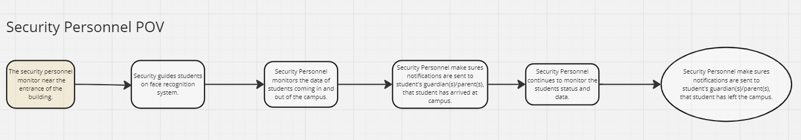

Figure 1: Current System flow (Security Personnel)

The security personnel have replaced manual attendance checks with a face recognition system. When students enter and exit the building, they look at the camera, easing the process and making it less hassle and more efficient. This change frees up security personnel's time from manual attendance checks, enabling them to concentrate on monitoring student data and ensuring everyone's whereabouts are known throughout the day.

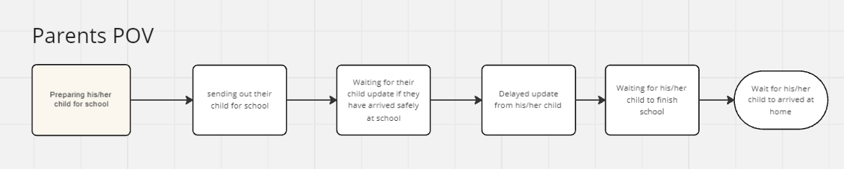

Figure 2: Current System flow (Parents)

The Parents, always worry about whether their children will arrive safely at school or not, a continual worry that keeps up until their child arrives at their home. The students cannot be blamed for their lack of urgency to update their parents, since their priority is learning. There is lack of other way to find solution to reassure parent regarding their child is something to focus on.

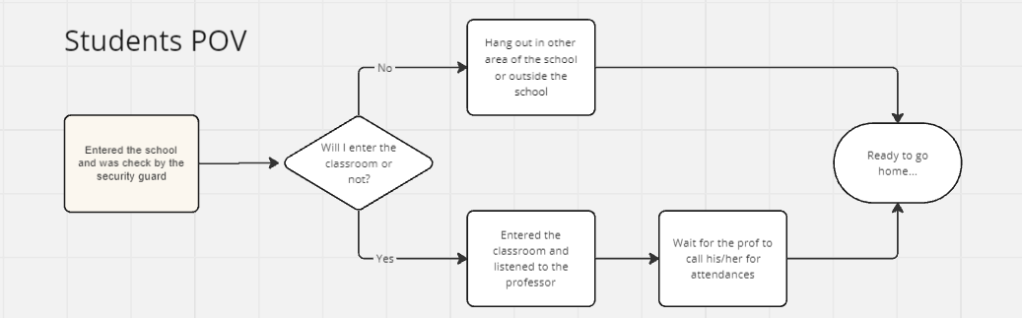

Figure 3: Current System of Face Track (Students)

The Students, have the capacity to choose whether they will attend their class online or onsite, in the environment of APC. This creates an opportunity to those to enter the school parameter but not in class, it is a high chance of risk, knowing that their parents think they are at school. While for others, attendance may take their time on learning more.

## Proposed System

The proposed system addresses the shortcomings of the current time-consuming and error-prone paper-based methods by automating attendance recording, ensuring data accuracy, and providing valuable insights into student attendance patterns. The system uses two programming languages: Java and Python. It also uses several libraries. The libraries used for face identification are facial recognition and OpenCV for Python (Mingtsung & Cai, 2020).The libraries used for the system's front end, the user interface, are Java and Android Studio.

Software

Android Studio(Front End)

In creating the user interface (UI), Android Studio was utilized, a powerful combination of Kotlin (or Java) and XML. Kotlin or Java is used to define the app's logic and functionality, while XML is used to describe the layout and structure of each screen. This combination allows developers to create interfaces that are easy to use and tailored specifically for the Android platform, making it a smooth and intuitive user experience. For instance, parents checking student records or admins verifying user data can benefit from this smooth and intuitive interface.

Java

Java is used to develop the very core features of the application and all its functions. It has been very significant for crafting the underlying logic and algorithms in the application. The functions of the application are comprehensive, but some deal with intuitively interfacing user interaction with intuitional interfaces, core data handling processes, and lots of other services that users give. Java's robustness and cross-platform compatibility allow it to manage such tasks effectively. It has a rich set of libraries that support quite several functionalities, ranging from designs of user interfaces to network communications.

Python(Back End)

For the software the system utilizes Python for its backend, which acts as the engine running the functionalities behind the scenes. Python itself handles various tasks including facial recognition, sending emails to parents, and recording student attendance data in the database.

OpenCV, a Python library, unlocks the capabilities of computer vision and machine learning for facial recognition. This allows the system to identify registered students stored in the database by comparing their faces with the stored data.

MySQL serves as the system's brain, storing crucial information like student names, ID numbers, and their attendance status. Python interacts with this database to record student entries and update attendance records.

Facial Recognition, another Python library, takes facial recognition a step further. It can detect faces within video frames and compare them against the student database for identification.

Hardware

For the project’s hardware we utilized A Webcam, A webcam is used so that the system can actually see and detect faces. This essential hardware continuously captures live video footage of students entering its designated area. The captured video feed is then analyzed by the system's software, focusing on facial recognition. This implemented facial recognition allows the system to identify students as they enter, making the webcam crucial for the core functionality of student recognition and identification.

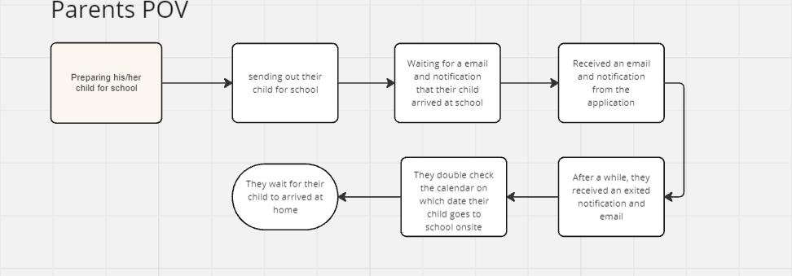

Figure 4: Proposed System of Face Track (Parents POV)

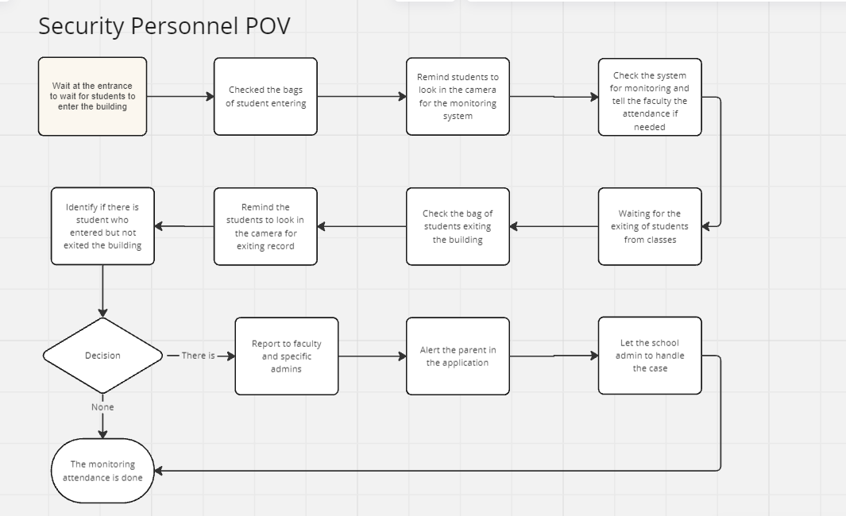

Figure 5: Proposed System of Face Track (Security Personnel POV)

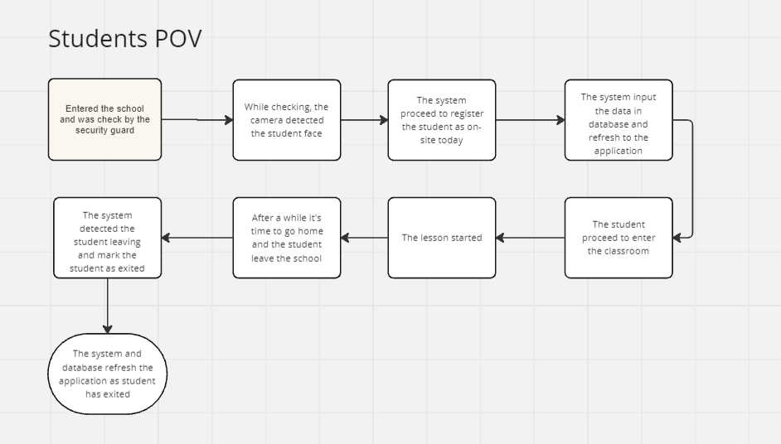

Figure 6: Proposed System of Face Track (Students POV)

# Conclusion

Developing and implementing a facial recognition attendance system aims to significantly improve security personnel's ability to track and record student presence on campus. This system addresses key security concerns such as unauthorized access and potential off-campus activity during school hours and provides real-time data to facilitate response to emergencies and provides automating attendance management with facial recognition that ensures an accurate and up-to-date data is readily available, allowing for a proactive approach to campus safety.

With this system, the technology will surpass the limitations of conventional methods by significantly mitigating the risk of unauthorized access through liveness detection, ensuring only registered students gain entry. Moreover, the system's ability of handling capacity of large data volumes and adapt to diverse conditions underscores its effectiveness across the entire implementation to the campus. Its integration with a centralized dashboard empowers security personnel to effortlessly monitor real-time attendance data, fostering quicker response times and enhanced situational awareness.

This system enhances not only security but also transparency and accountability within the educational environment. The system will benefit the students, parents, faculty but most importantly, the security personnel. Focusing on accurate data and efficient operations. The facial recognition attendance system revolutionizes security protocols at Asia Pacific College by providing a modern, efficient, and security-focused solution. This system positions the institution as a leader in prioritizing student safety and demonstrates its commitment to a secure and technologically advanced learning environment. Overall, the successful implementation of this system will become a way to a safer and more secure campus community.

In conclusion, the facial recognition attendance system stands to revolutionize attendance management at Asia Pacific College by providing a modern, efficient, and user-centric solution. This system not only addresses current challenges but also positions the institution as a forward-thinking and technologically advanced entity. By embracing such innovative solutions, Asia Pacific College can enhance its reputation and attract security personnels, students, faculty, and partners who value safety, efficiency, transparency, and technological advancement. Overall, the successful implementation of this system will significantly contribute to a more efficient, modern, and engaging educational environment.

**Recommendations:**

**Security Personnel Login**

Login Screen:

* Indicate Assigned Area: Display the security personnel's assigned area or zone (e.g., "Main Gate", "West Wing").
* Recent Activity Log: Show a brief log of recent security events or access requests in the assigned area.

Security Dashboard:

* Live Camera Feed Grid: Display a grid layout with live camera feeds from key areas for real-time monitoring.
* Interactive Floor Plan: Integrate an interactive floor plan with real-time location indicators for personnel and potential incidents.
* Search Bar with Filters: Allow searching for incidents, personnel, or access requests with relevant filters (e.g., date, location, type).

Incident Management:

* Provide a streamlined interface for creating incident reports with pre-defined options and file upload capabilities.
* Real-time Incident Tracking: Track ongoing incidents on a map with updates and status changes.
* Access Control View: Monitor access attempts and approvals for restricted areas in real-time.

**Faculty Feature Access**

Faculty Login:

* + Indicate faculty section (surname followed by section)
  + Grid layout for faculty list
  + Search bar with icon

Student Attendance:

* + Daily attendance view for each section
  + Records for all sections

Parent Portal:

* + Future enhancement: Allow managing multiple children (siblings) within a single account

**System Enhancements:**

Presentation Mode:

* + Implement a presentation mode that allows for smooth transitions between slides
  + Consider using a different facial recognition method to ensure accurate detection under various conditions

Testing and Debugging:

Thorough Testing:

* + Identify and address potential weak points and limitations of the system
  + Anticipate user queries and prepare comprehensive responses
  + Test the system from different angles and scenarios
  + Always provide solutions to any issues that arise
  + Conduct remote testing to ensure system functionality across various devices and network conditions

Prioritize Testing on Mobile Devices:

* Considering the increasing prevalence of smartphone usage, ensure the system is optimized and functions seamlessly on mobile devices.

Demonstrate System Functionality:

* Prepare a comprehensive demonstration showcasing the system's features and capabilities
* Utilize this demonstration to gather feedback and identify areas for improvement

Continuous Improvement:

* Adopting an iterative development approach, incorporating feedback and testing results into ongoing refinements
* Striving for constant improvement of the system's usability, performance, and overall user experience.
* Visitor Pre-Registration: Allow pre-registration of expected visitors with photo ID and purpose of visit.

# References

[1] Ancheta, R. F., Daniel, D., & Ahmad, R. (2021). Effect of Class Attendance on Academic Performance. *European Journal of Education Studies*, 8(9), 1234-1245. [doi: 10.46827/ejes.v8i9.3887]

[2] Nguyen, D. D., Nguyen, X. H., Than, T., & Nguyen, M. S. (2021). Automated attendance system in the classroom using artificial intelligence and internet of things technology. In *2021 8th NAFOSTED Conference on Information and Computer Science (NICS)* (pp. 1-6). Institute of Electrical and Electronics Engineers (IEEE). [doi: 10.1109/nics54270.2021.9700991]

[3] Mingtsung, C., & Cai, L. (2020). Research on the application of face recognition system. In *Proceedings of the 2020 5th International Conference on Humanities Science and Society Development (ICHSSD 2020)* (pp. 123-128). Atlantis Press. [doi: 10.2991/assehr.k.200727.057]

[4] Zuanuwar, S. H. B. M. (2020). The influence student attendance management system on academic performance. *Journal of Social Transformation and Education*, 1(1), 1-10. [doi: 10.54480/jste.v1i1.3]

# Appendices

## Appendix A: Project Vision

**Imagine a school where mornings feel effortless. No more scrambling for lost ID cards or waiting in long check-in lines. Leantech’s vision is a secure and user-friendly system that utilizes facial recognition technology to transform student arrivals.**

Students walk confidently towards the school entrance, greeted by a welcoming system that recognizes them instantly. Parents can breathe a sigh of relief, receiving real-time notifications on their phones confirming their child's safe arrival through a companion app. Meanwhile, school administrators and security personnel have access to a user-friendly platform displaying real-time attendance and monitoring onsite data. This not only enhances security by controlling building access but also streamlines the process, allowing educators to identify potential absences quickly and dedicate more time to creating a positive learning environment.

**However, student privacy is paramount.** We'll implement industry-standard protocols and prioritize transparency. Clear communication and opt-in/opt-out procedures will ensure everyone understands how the system works and feels comfortable with its implementation.

**The ultimate goal?** Creating a welcoming and efficient school environment that fosters student safety builds parental confidence and empowers educators with improved administrative capabilities. This innovative approach strengthens the school community and allows everyone to focus on what truly matters – fostering a thriving learning experience for every student.

## Appendix B: Schedule

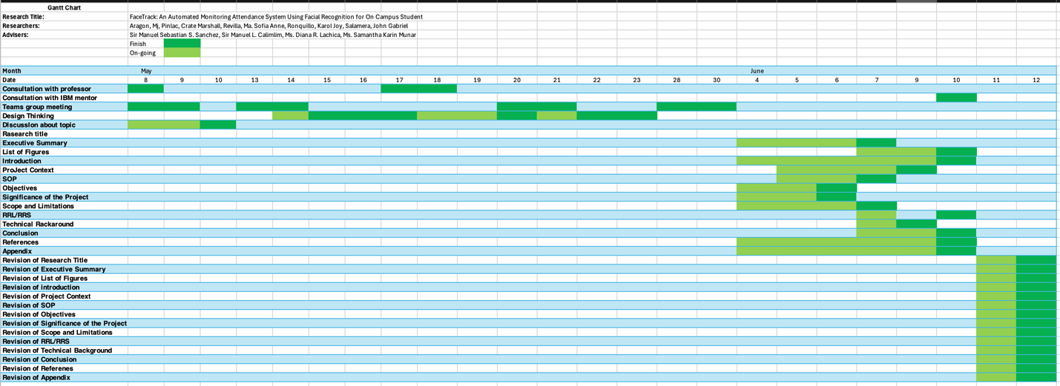

Figure 7: Gantt Chart

## Appendix C: Product Roadmap

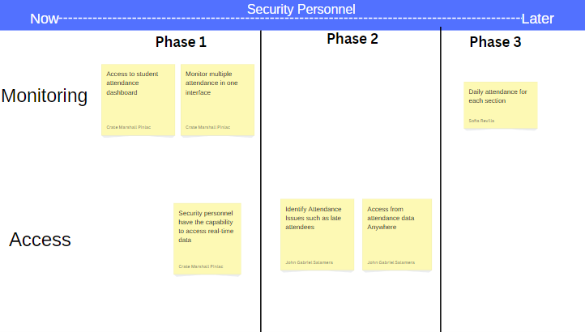

Figure 8: Product Roadmap (Security Personnel)

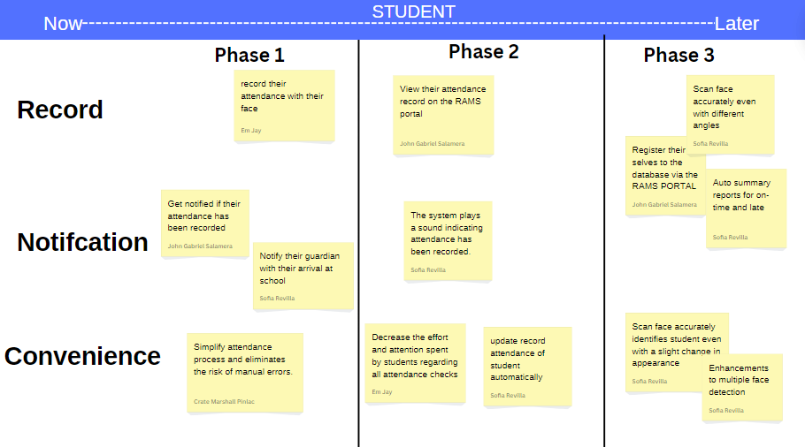

Figure 9: Product Roadmap (Student)

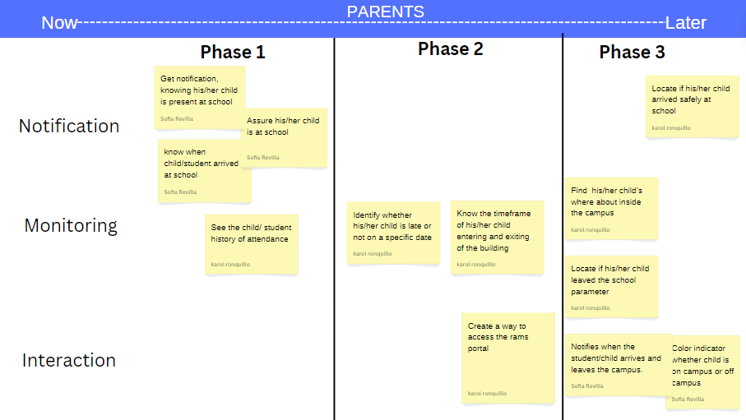

Figure 10: Product Roadmap (Parents)

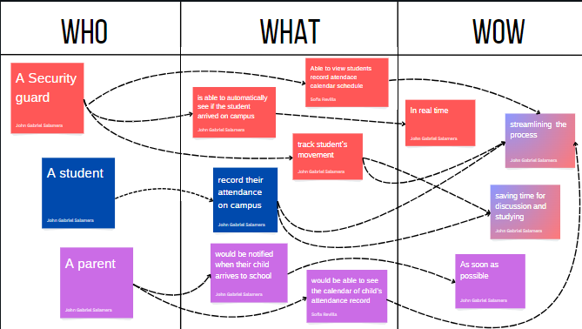

Figure 11: Hill diagram of Security Personnel, student, parents

Appendix D: Users’ Manual

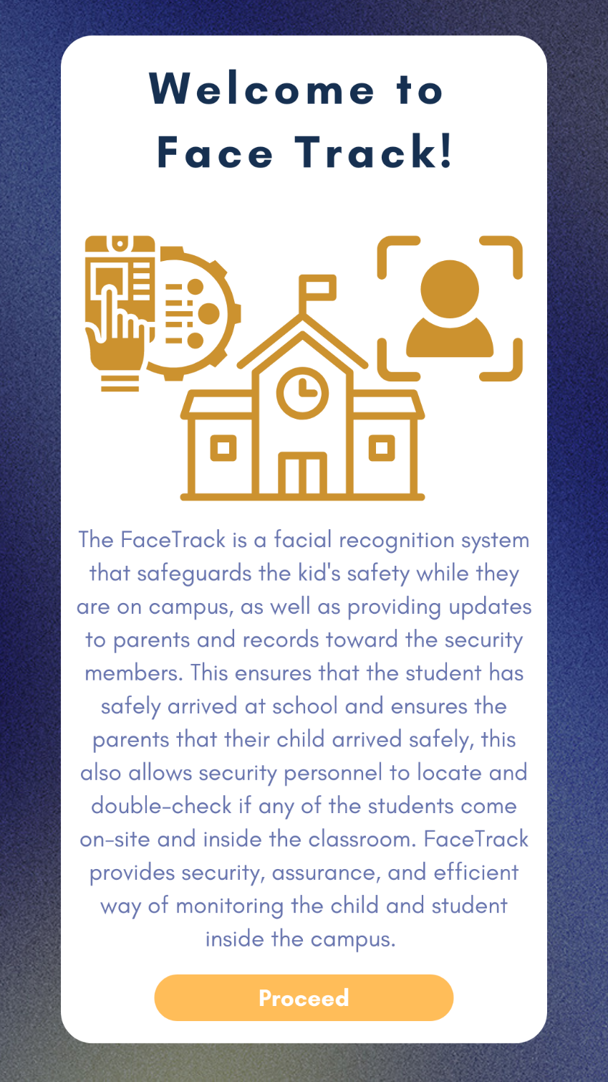

Figure 12: User Manual (Introduction)

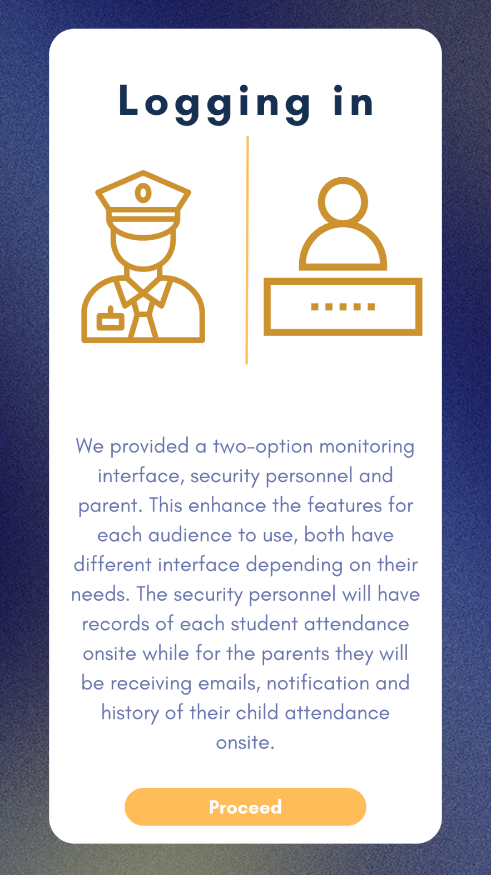

Figure 13: User Manual (Logging in)

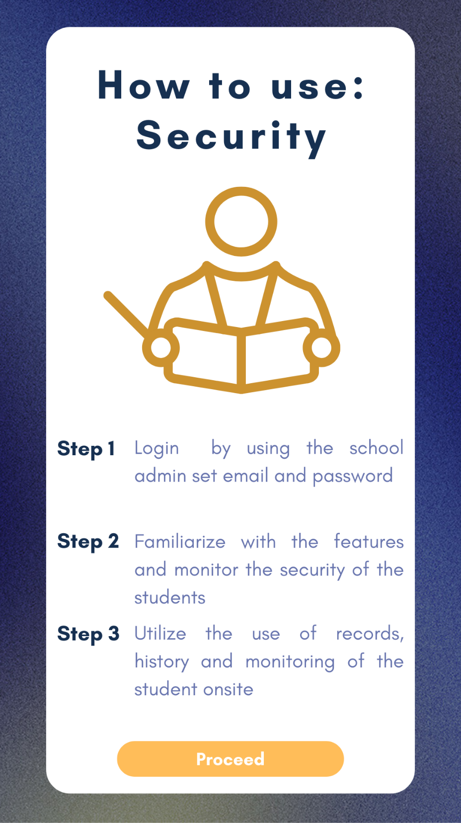

Figure 14: User Manual (Security Personnel)

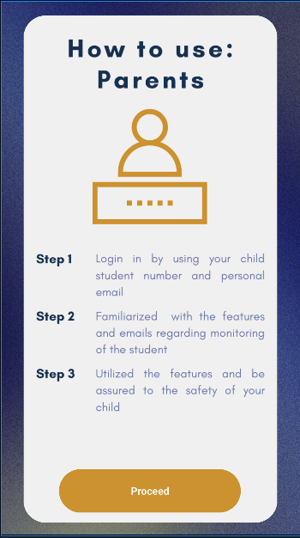

Figure 15: User Manual (Parents)

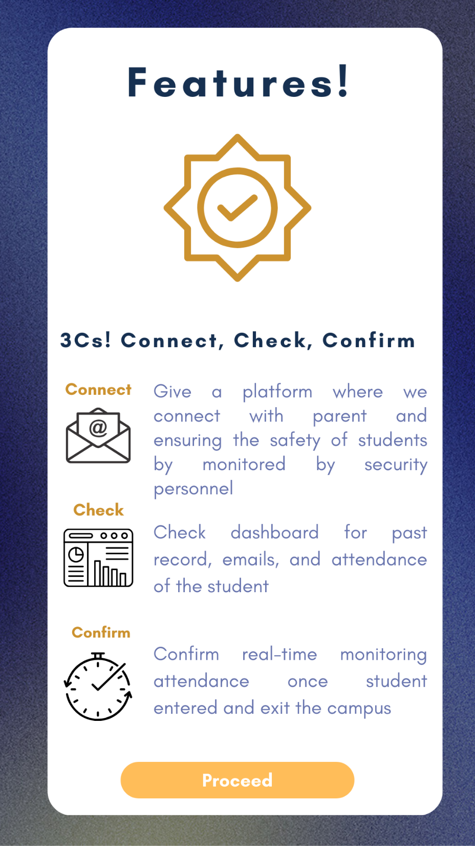

Figure 16: User Manual (Features)

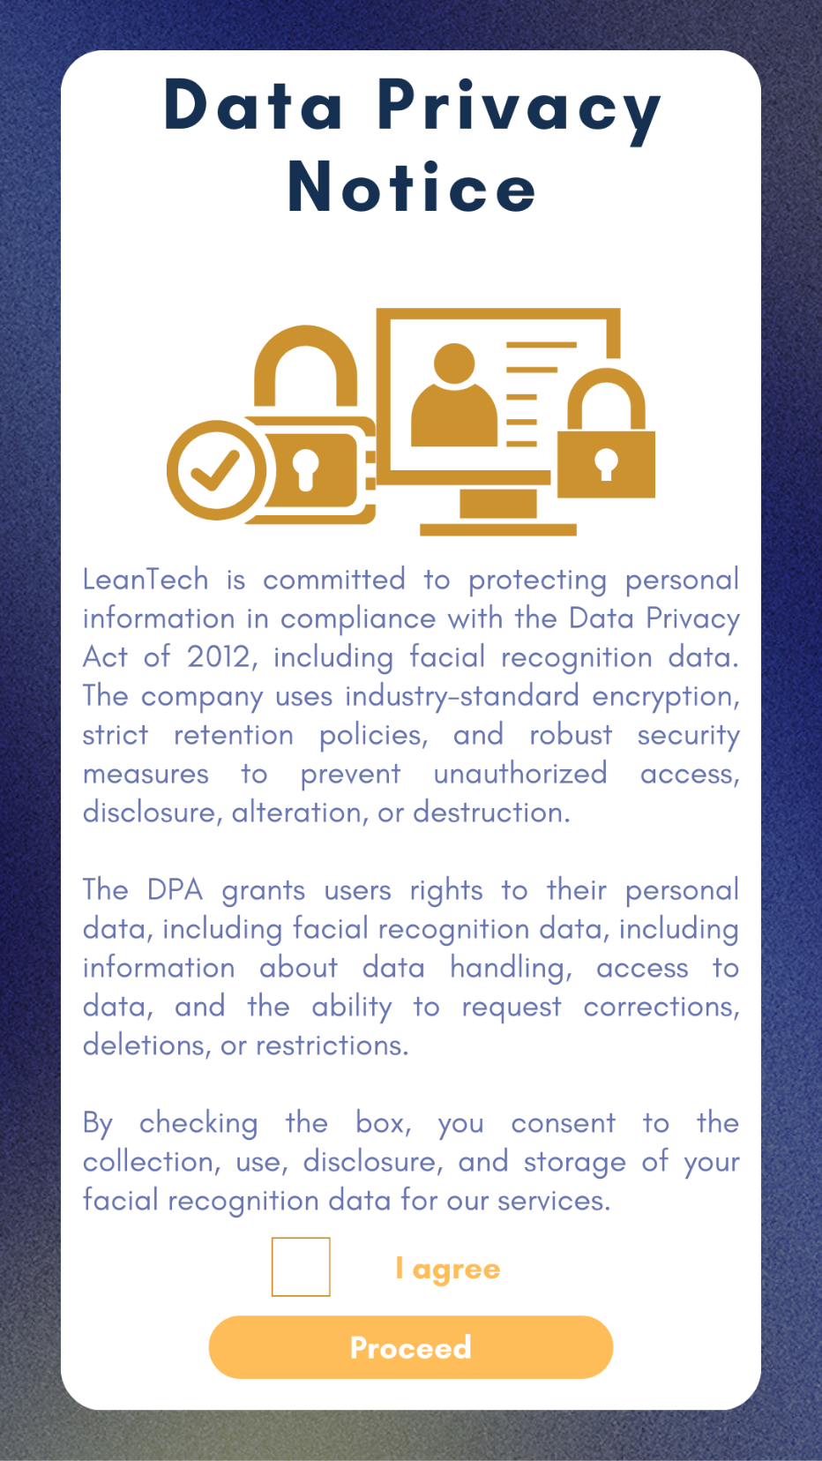

Figure 17: User Manual (Data Privacy Notice)

## Appendix E: Team Meetings

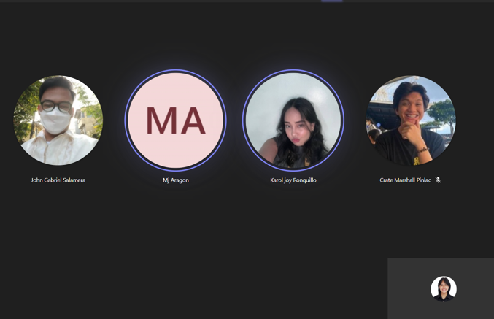

Figure 18: Team Meetings (May 8, 2024)

**May 8, 2024**  
Time: 7:30pm – 8:00pm  
Duration: 30 minutes  
ATTENDEES:

* Aragon, Mj
* Pinlac, Crate Marshall
* Revilla, Ma. Sofia Anne
* Ronquillo, Karol Joy
* Salamera, John Daniel

ABSENT:

* None

Agenda:

* Group discussion
* Project planning

Summary: The team discussed the project's overall direction and brainstormed initial ideas. Each member shared their insights and suggestions for improving the project structure. A rough timeline was drafted, and responsibilities were tentatively assigned.

Next Meeting:

* Continue project planning
* Assign detailed tasks

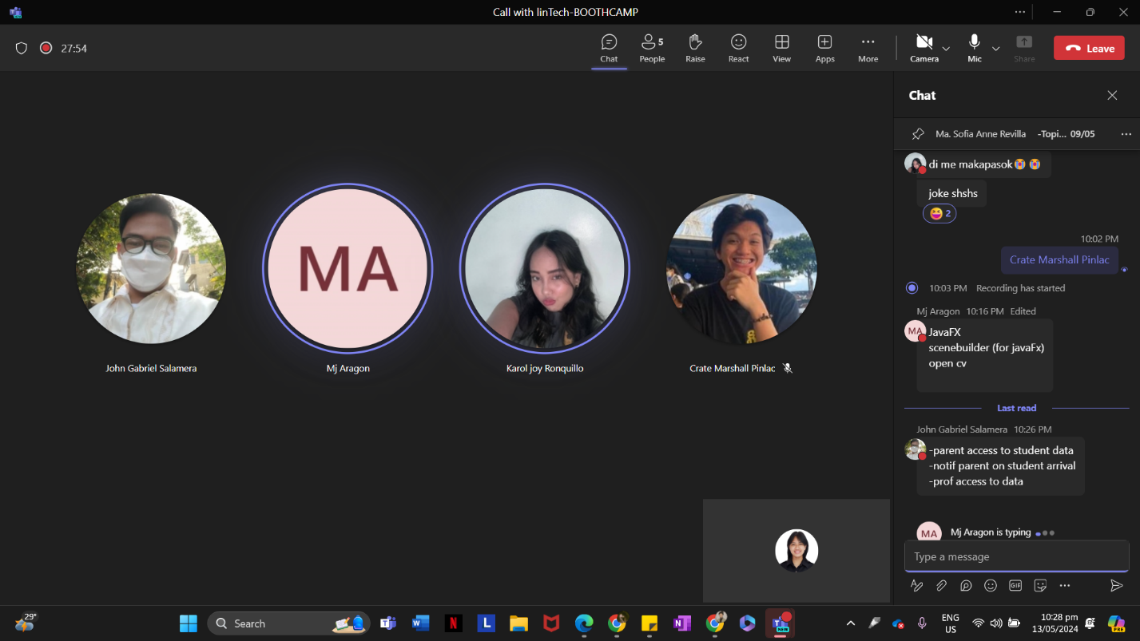

Figure 19: Team Meetings (May 9, 2024)

**May 9, 2024**  
Time: 10:40pm – 11:43pm  
Duration: 1 hour and 3 minutes  
ATTENDEES:

* Aragon, Mj
* Pinlac, Crate Marshall
* Revilla, Ma. Sofia Anne
* Ronquillo, Karol Joy
* Salamera, John Daniel

ABSENT:

* None

Agenda:

* Group discussion
* Finalizing initial project
* Preparation for presentation

Summary: The group has finalized the draft version of the project, ensuring that the features will be demonstrated in the demo, effectively conveying the initial project idea. Additionally, members rehearsed the presentation script, identified areas needing refinement, and ensured that each member was confident in their role.

Next Meeting:

* Review feedback from presentation
* Plan final project adjustments

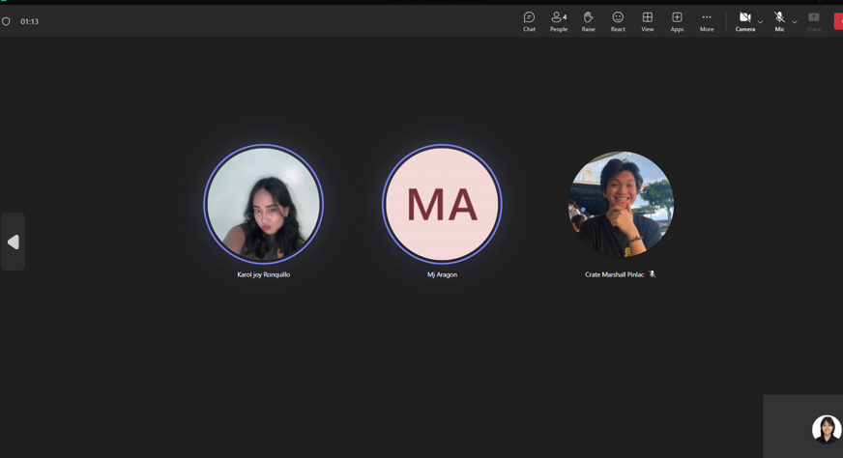

Figure 20: Team Meetings (May 13, 2024)

**May 13, 2024**  
Time: 10:25pm – 11:17pm  
Duration: 52 minutes  
ATTENDEES:

* Aragon, Mj
* Pinlac, Crate Marshall
* Revilla, Ma. Sofia Anne
* Ronquillo, Karol Joy
* Salamera, John Daniel

ABSENT:

* None

Agenda:

* Recap of feedback from presentation
* Finalizing project
* Distribution of tasks

Summary: Feedback from the presentation was reviewed, and necessary changes were implemented. The project was finalized, and tasks for the remaining deliverables were distributed among the team members.

Next Meeting:

* Review final project adjustments
* Plan next steps



Figure 21: Team Meetings (May 14, 2024)

**May 14, 2024**  
Time: 10:00pm – 10:30pm  
Duration: 30 minutes  
ATTENDEES:

* Aragon, Mj
* Pinlac, Crate Marshall
* Revilla, Ma. Sofia Anne
* Ronquillo, Karol Joy
* Salamera, John Daniel

ABSENT:

* None

Agenda:

* Collecting sources
* Researching
* Update on progress of project

Summary: Members presented their collected sources and discussed the quality and relevance of the materials. The group conducted research sessions to fill in any gaps identified in previous meetings. Progress updates were shared, with members highlighting any issues faced and potential solutions.

Next Meeting:

* Review research findings
* Plan next steps

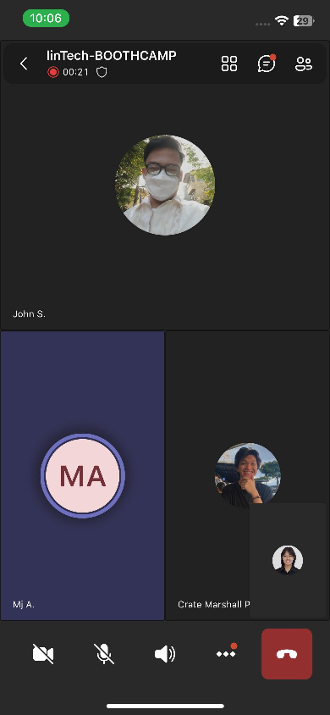

Figure 22: Team Meetings (May 20, 2024)

**May 20, 2024**  
Time: 9:00pm – 9:25pm  
Duration: 25 minutes  
ATTENDEES:

* Aragon, Mj
* Pinlac, Crate Marshall
* Revilla, Ma. Sofia Anne
* Ronquillo, Karol Joy
* Salamera, John Daniel

ABSENT:

* None

Agenda:

* Update on progress of project
* Checking for concerns

Summary: Each member gave an update on their assigned tasks, discussing any challenges faced. The team addressed concerns, ensuring everyone had the support and resources needed to complete their tasks efficiently.

Next Meeting:

* Review progress updates
* Plan next steps

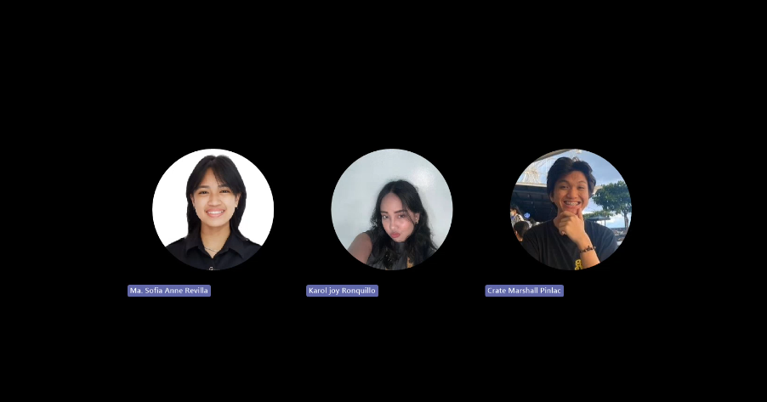

Figure 23: Team Meetings (May 21, 2024)

**May 21, 2024**  
Time: 9:00pm – 11:05pm  
Duration: 3 hours and 5 minutes  
ATTENDEES:

* Aragon, Mj
* Pinlac, Crate Marshall
* Revilla, Ma. Sofia Anne
* Ronquillo, Karol Joy
* Salamera, John Daniel

ABSENT:

* None

Agenda:

* Preparation for roleplay demo
* Consultation

Summary: The team prepared for the roleplay demo, practicing different scenarios and refining their performances. Consultations were held to ensure the demo was aligned with project objectives and to get feedback from advisors.

Next Meeting:

* Review demo feedback
* Plan final adjustments



Figure 24: Team Meetings (May 28, 2024)

**May 28, 2024**Time: 9:30am – 10:30am  
Duration: 1 hour  
ATTENDEES:

* Aragon, Mj
* Pinlac, Crate Marshall
* Revilla, Ma. Sofia Anne
* Ronquillo, Karol Joy
* Salamera, John Daniel

ABSENT:

* None

Agenda:

* Meeting with professor

Summary: The team met with a professor to receive final feedback on the project. The professor provided valuable insights and suggestions for further refinement. The team discussed implementing these suggestions and planned the final steps to ensure project success.

Next Meeting:

* Review professor's feedback
* Plan implementation steps

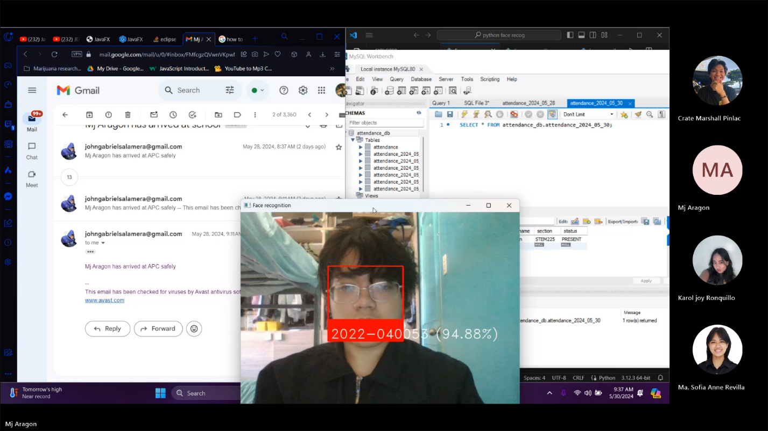

Figure 25: Team Meetings (May 30, 2024) with sample of facial recognition system

**May 30, 2024**  
Time: 8:07am – 9:40am  
Duration: 1 hour and 47 minutes  
ATTENDEES:

* Aragon, Mj
* Pinlac, Crate Marshall
* Revilla, Ma. Sofia Anne
* Ronquillo, Karol Joy
* Salamera, John Daniel

ABSENT:

* None

Agenda:

* Meeting with IBM mentor

Summary: The team met with the IBM mentor onsite, to get expert advice on the project. The mentor provided insights into the technical aspects and suggested innovative approaches to enhance the project's effectiveness. The team discussed these suggestions and planned the final implementation steps.

Next Meeting:

* Review mentor's suggestions
* Plan final implementation

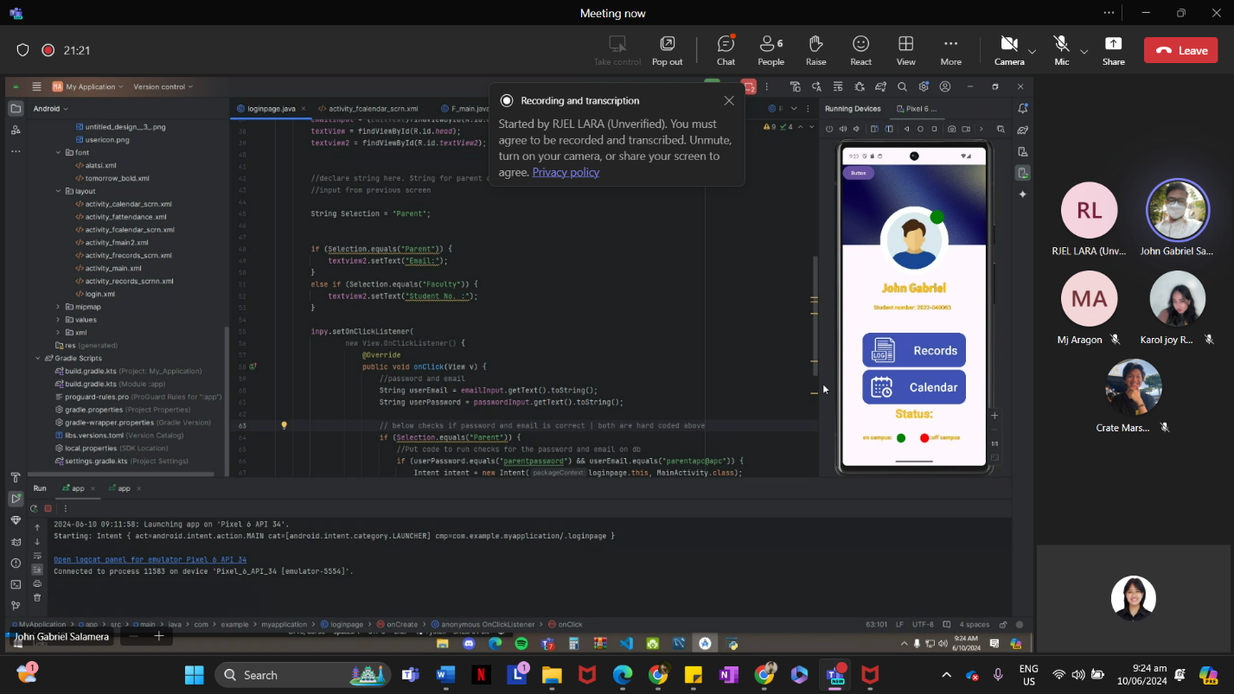

Figure 26: Meeting with IBM Mentor

**June 10, 2024**Time: 9:00am – 10:00am  
Duration: 1 hour  
ATTENDEES:

* Aragon, Mj
* Pinlac, Crate Marshall
* Revilla, Ma. Sofia Anne
* Ronquillo, Karol Joy
* Salamera, John Daniel

ABSENT:

* None

Agenda:

* Consulting with IBM mentor

Summary: The team consulted with the IBM mentor for final guidance and feedback on their project. The mentor reviewed the progress and provided additional advice on optimization and presentation. The team planned the final steps to incorporate this feedback and ensure the project's success.

Next Meeting:

* Finalize project adjustments
* Plan presentation strategie

## Appendix F: Source Code

<https://github.com/H0wlie/Face-track-front-end>

<https://github.com/H0wlie/Face-track>

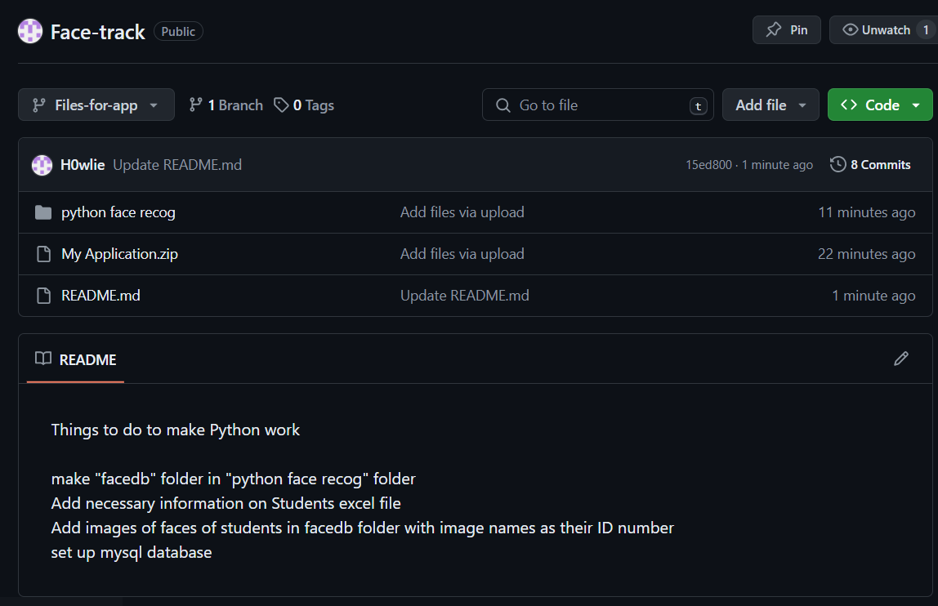

Figure 27: Github Face Track

## Appendix G: Marketing Plan/Study

The traditional method of taking attendance can be time-consuming and potentially consume valuable class time. Parents also frequently express concerns about their child's safe arrival at school. Additionally, the use of paper-based attendance systems can be inconvenient and error-prone. Therefore, LeanTech's Automated Monitoring Attendance System utilizing Secure Facial Recognition offers an innovative solution to these challenges. This cutting-edge system represents a significant advancement, liberating educational institutions from old-fashioned methods and permitting a focus on the essential aspects of student safety, well-being, and learning. Embracing this technology can propel schools into a promising future of enhanced efficiency and overall progress.

By implementing our system, your school can benefit in numerous ways. Effortless Attendance Management is one key aspect. Our user-friendly system automates attendance recording, freeing teachers and administrators to focus on students. Plus, it requires minimal setup, making implementation a breeze. Real-time data and insights can help you gain valuable information on student attendance patterns, proactively support students, and make informed decisions. You can also identify potential issues like tardiness or absences early on and intervene effectively. Enhanced Communication is another advantage, providing parents with instant notifications when their child arrives at school and alerting them if their child leaves school grounds during unauthorized times. This ensures their safety at all times, giving parents the peace of mind they deserve. Increased Security is also a feature, with accurate student identification and preventing unauthorized access strengthening campus security. Our facial recognition technology adds an extra layer of protection compared to traditional methods.

Say goodbye to paper-based attendance and the frustration of "buddy punching." With our efficient and reliable system, you can enjoy a smoother workflow. LeanTech's Automated Attendance System is an investment in your school's success. It fosters a more connected and secure learning environment by empowering teachers, informing parents, and engaging students. Moreover, our system prioritizes student privacy and adheres to all relevant data security regulations.

LeanTech is just one contact away! Reach out for a free demo and see how our system can benefit your school community. Our dedicated representatives are ready to discuss how our secure facial recognition technology can address your needs. Also, visit our website to download our free white paper on the advantages of facial recognition attendance systems in education. Discover the latest research and insights on how facial recognition technology improves school safety and efficiency.

## Appendix H: Use Case Full Description

|  |  |  |
| --- | --- | --- |
| Use case name | *Mark attendance on campus* | |
| Scenario | Records the students’ attendance on campus | |
| Triggering event | When the system detects the students’ face | |
| Brief description | When the system detects the students’ face it goes through the facial recognition algorithm and then sends an email to the parents as well as record the attendance | |
| Actors | Student, Parent | |
| Related Use cases | Includes: *monitoring students’ attendance (*Security personnel*)*  *Monitoring students’ attendance (parent)* | |
| Stakeholders | Parents and school Faculty | |
| Preconditions | The system must be set up already before students arrive.  Students’ information must be in the face recognition system.  Wi-Fi connection in the place of the system should be strong enough.  Users must agree to Data Privacy Act | |
| Post conditions | Students’ attendance must be marked in the database  Students’ Parents should receive an email that says their son/daughter has arrived at school | |
| Flow of activities | Actors | System |
|  | 1. student arrives on campus  2. Guard Checks student’s bag  3. student enters on campus  4. Parents check email from system | 3.1 system detects and recognizes the student’s face  3.2 system marks student’s attendance to database  3.3 system sends email to parents that their child has arrived. |
| Exception conditions | 1. student attended class online 2. If the student does not exist in the face recognition database, the guard will double check his info and can accompany him to the ITRO to be registered | |

|  |  |  |
| --- | --- | --- |
| Use case name | *monitoring students’ attendance (Security personnel)* | |
| Scenario | School faculty can monitor students’ attendance on campus | |
| Triggering event | When the system detects the students’ face | |
| Brief description | When the system detects the students’ face it goes through the facial recognition algorithm and then records their attendance. It can also detect whether they went outside the campus | |
| Actors | Student, Security personnel | |
| Related Use cases | Includes: *Mark attendance on campus*  *Monitoring students’ attendance (parent)* | |
| Stakeholders | Parents and Security personnels | |
| Preconditions | Security personnels should have their apps downloaded  Their devices must be connected to the internet | |
| Post conditions | Students’ attendance must be marked in the database | |
| Flow of activities | Actors | System |
|  | 1. students arrive at school  2. Security personnels checks app to see all of the students attendance on campus | 1.1 system detects students’ face and record their attendance to the database  2.2 the app can show the students attendance as well as if the students exited or entered the campus and also when they arrived on campus |
| Exception Conditions | 1. if the student attended online |  |

|  |  |  |
| --- | --- | --- |
| Use case name | *monitoring students’ attendance (parents)* | |
| Scenario | Students’ parents can monitor students’ attendance on campus | |
| Triggering event | When the system detects the students’ face | |
| Brief description | When the system detects the students’ face it goes through the facial recognition algorithm and then the system sends an email to the parent that their child has arrived and mark their attendance in the database | |
| Actors | Parents, students | |
| Related Use cases | Includes: *Mark attendance on campus*  *Monitoring students’ attendance (Security personnel)* | |
| Stakeholders | Parents and Security personnels | |
| Preconditions | parents have the apps downloaded  Their devices must be connected to the internet | |
| Post conditions | Students’ attendance and activity will be shown in the app | |
| Flow of activities | Actors | System |
|  | 1. students arrive at school  2. parents checks app to see their child’s attendance and monitor them | 1.1 system detects students’ face and record their attendance to the database  2.2 the app can show their child’s attendance as well as if their child exited or entered the campus and also when they arrived on campus |
| Exception Conditions | 1. if their child attended online  2. the student is absent |  |

## Appendix I: Design Thinking

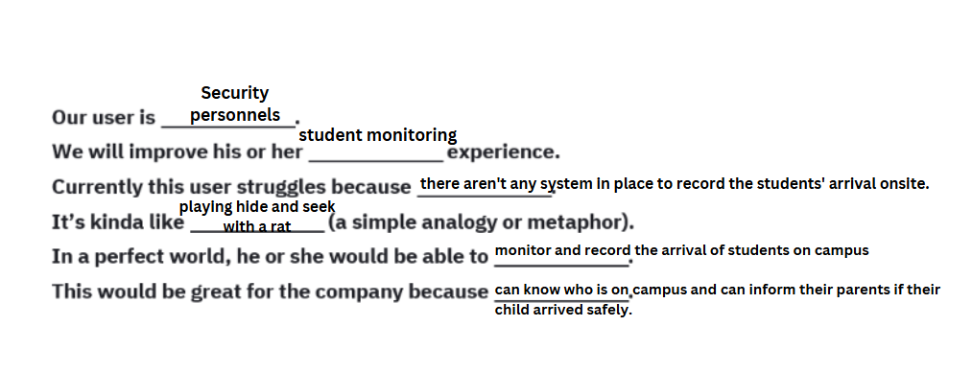

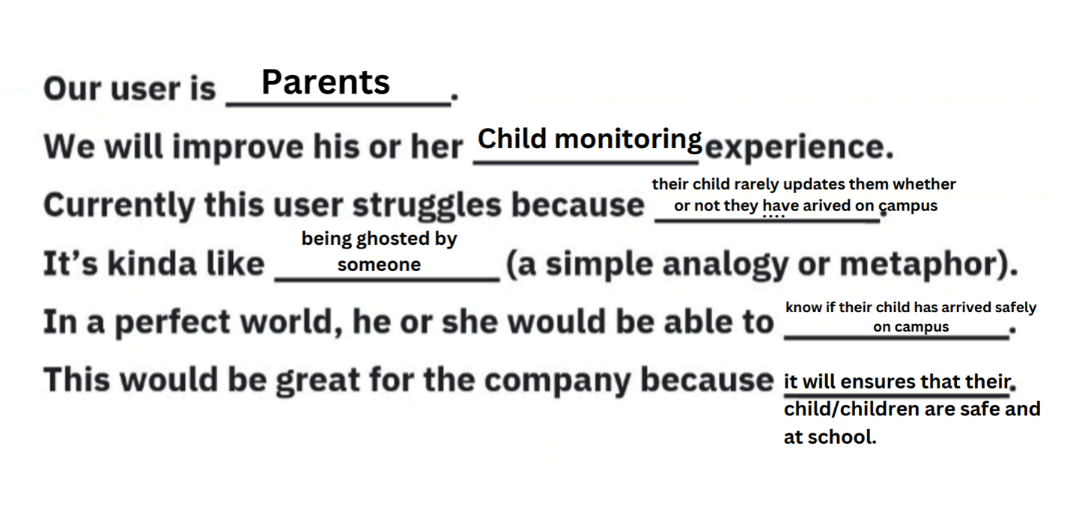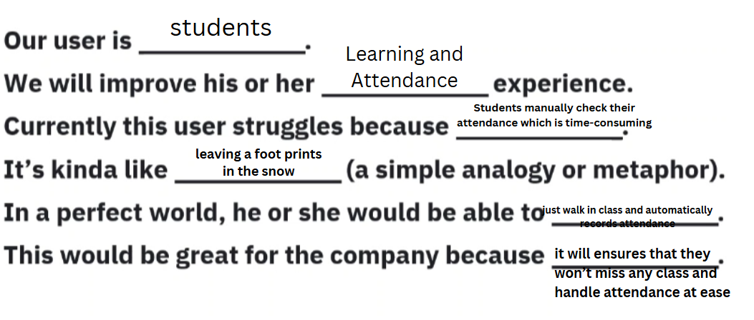

Figure 28: Problem Rundown of Security Personnel, Parents and Students

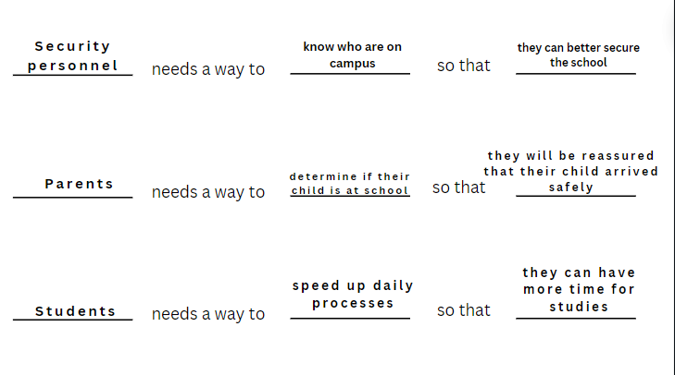

Figure 29: Need Statements of Security Personel, Parents and Students

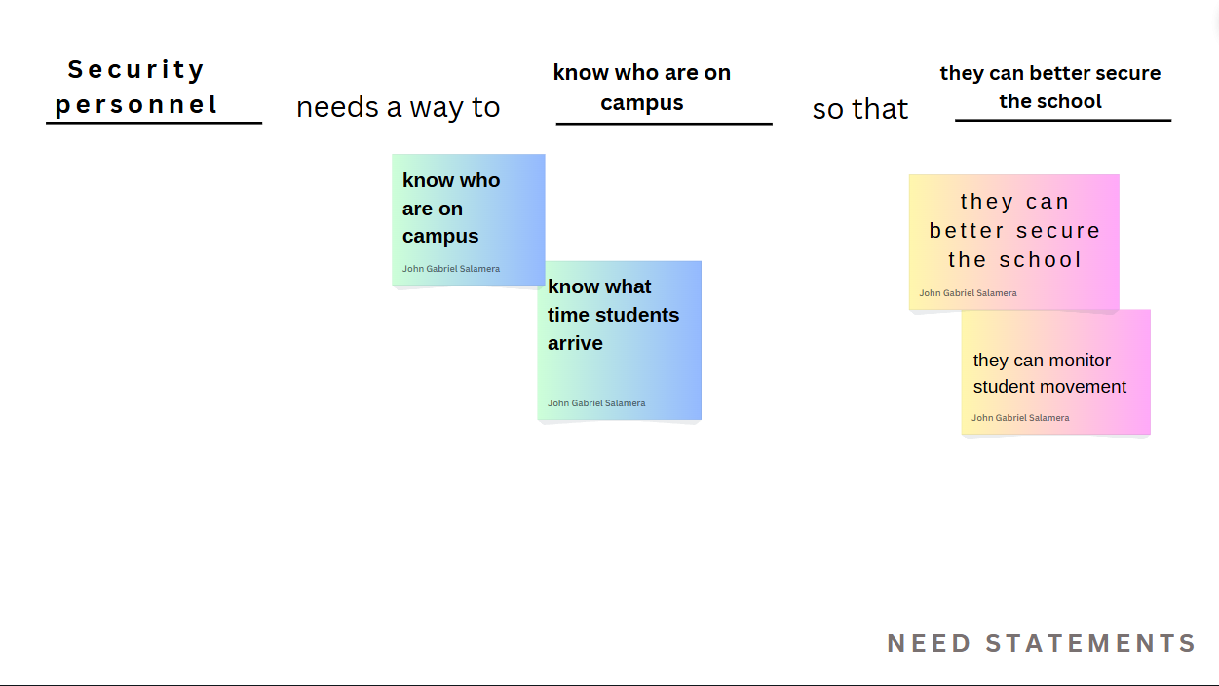

Figure 29: Need Statements (Security Personnel)

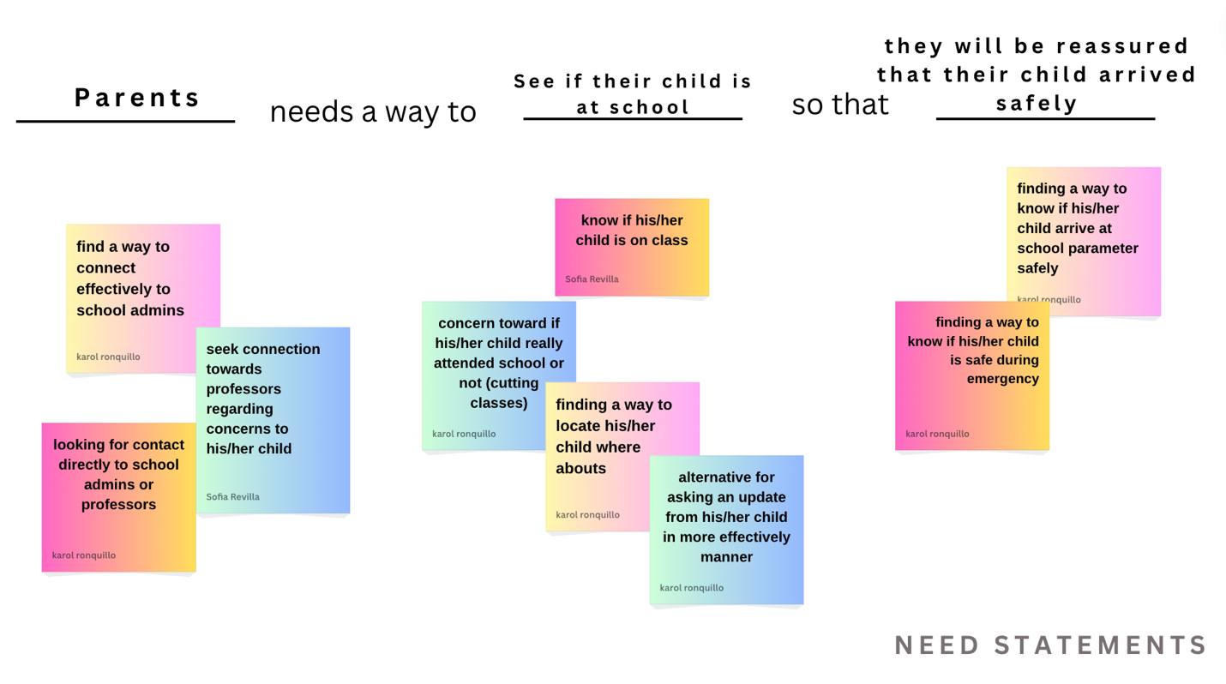

Figure 30: Need Statements (Parents)

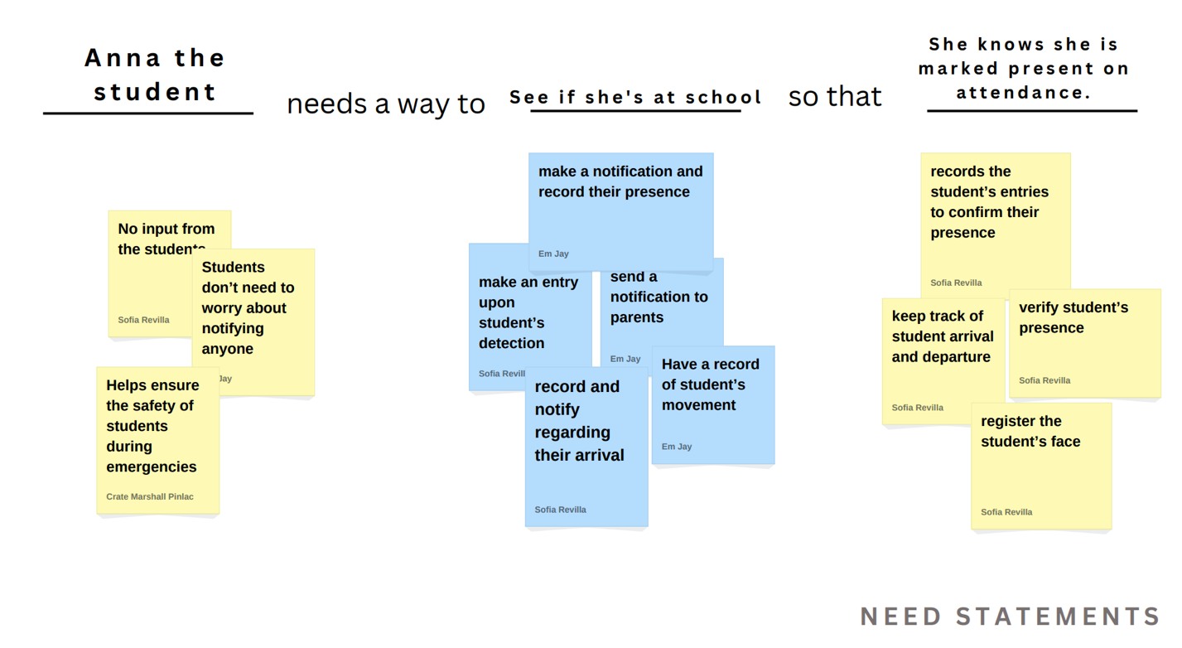

Figure 31: Need Statements (Students)

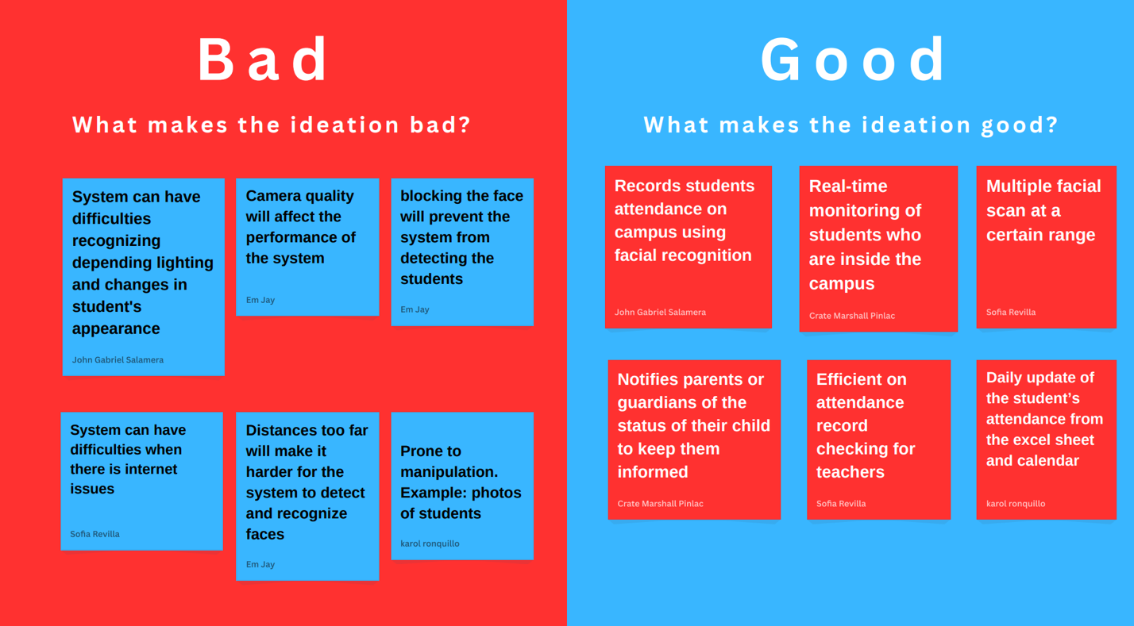

Figure 32: The good and bad ideation of Face Track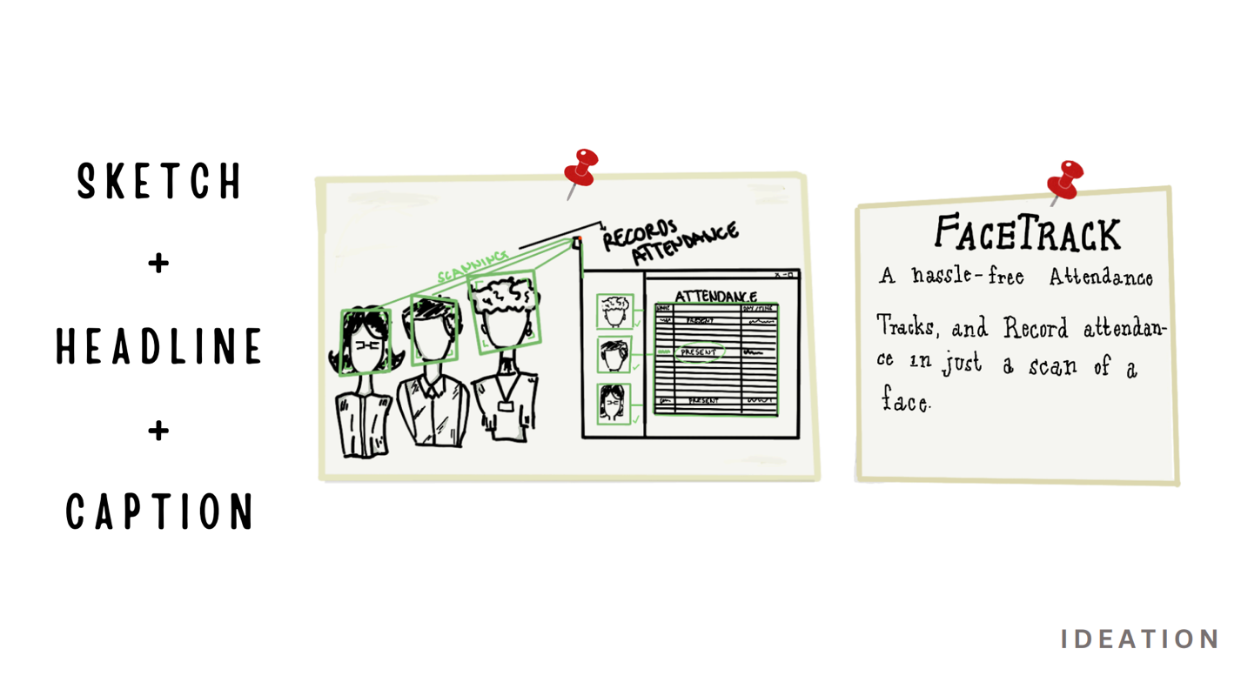

Figure 33: Sketch of Face Track (1)

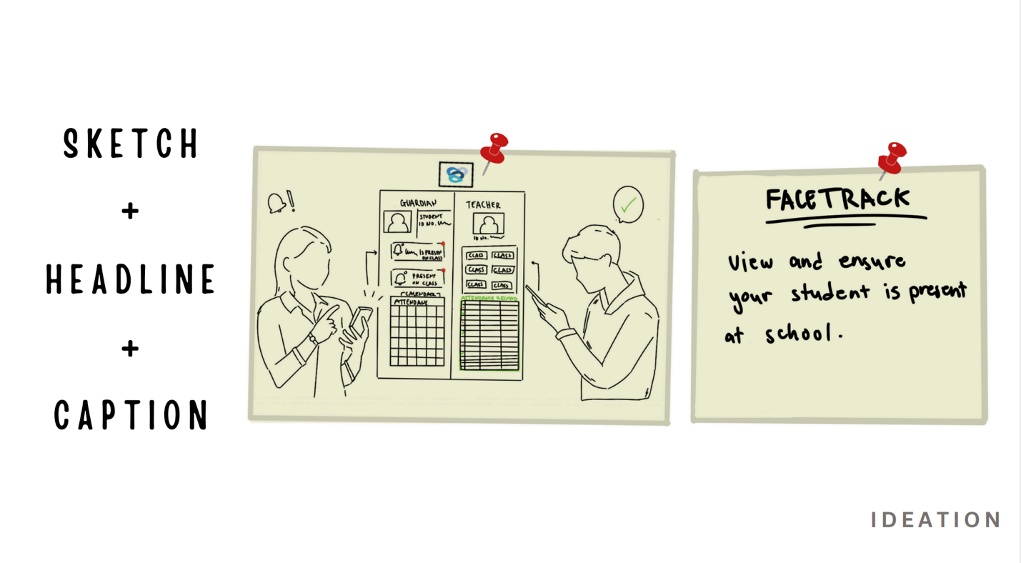

Figure 34: Sketch of Face Track (2)

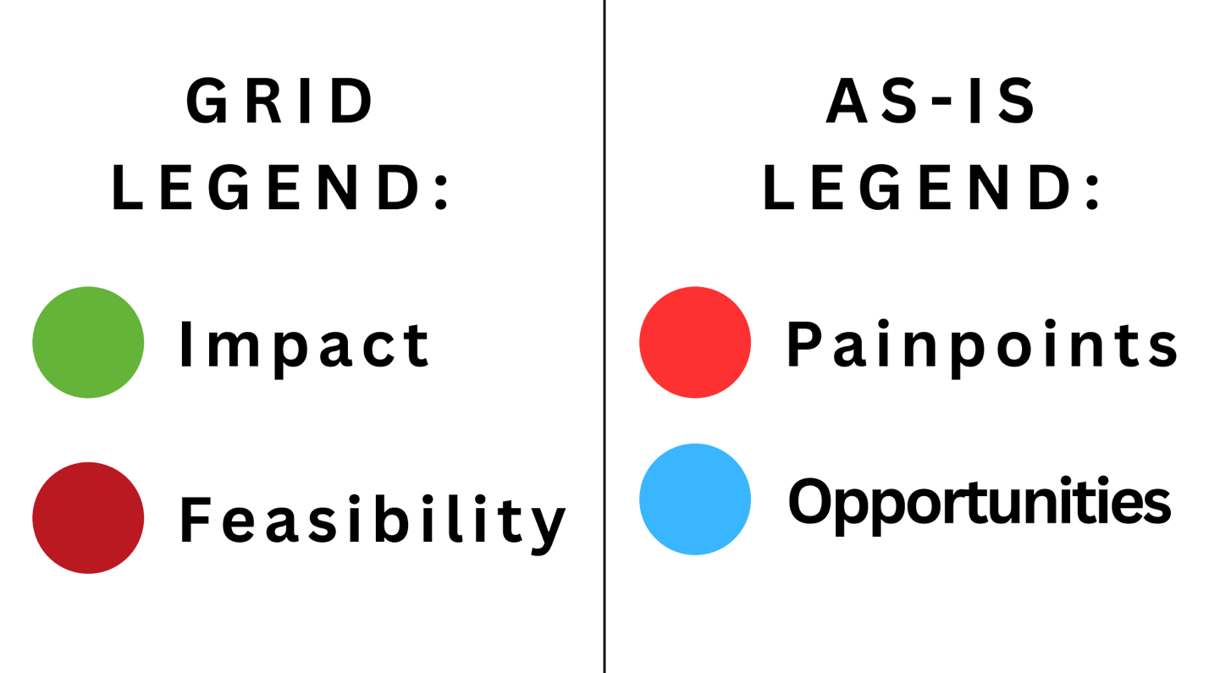

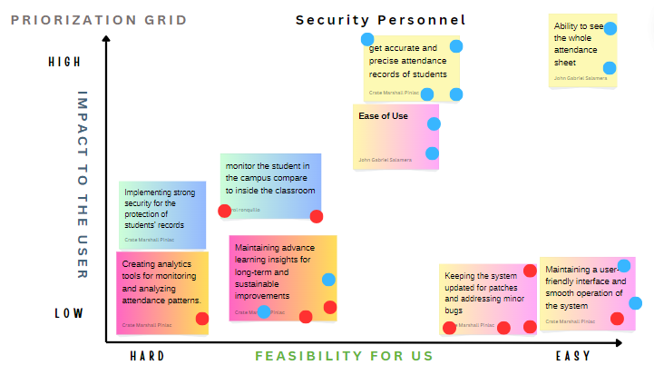

Figure 35: Prioritization Grid (Security Personnel)

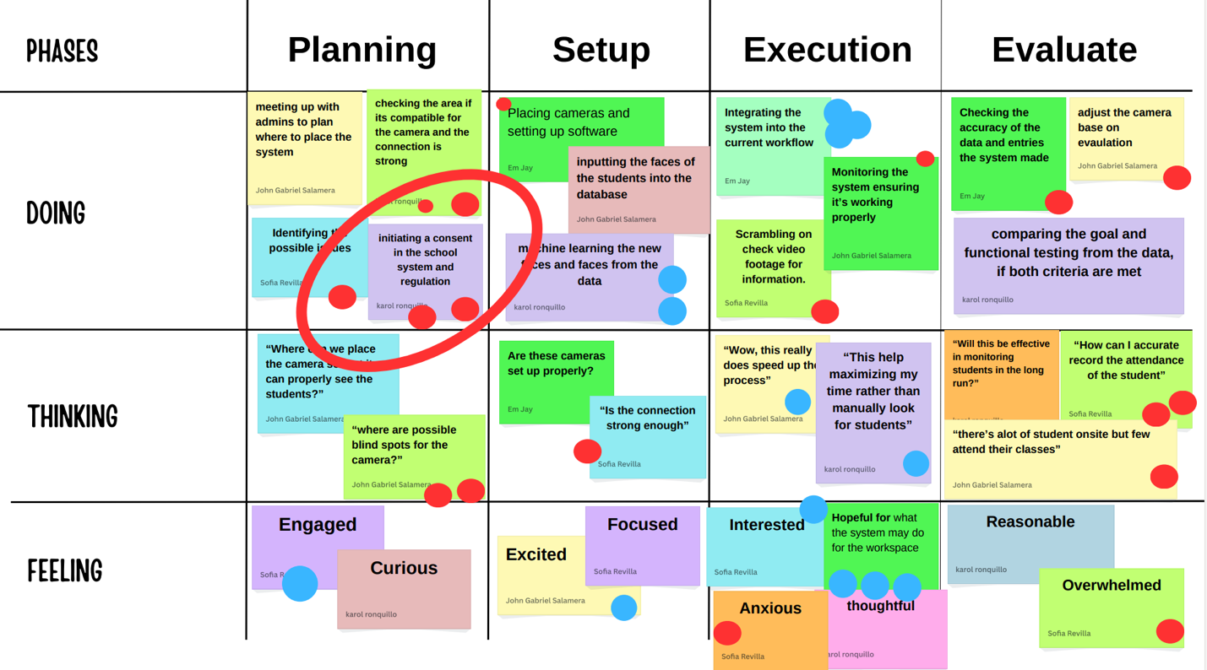

Figure 36: Scenario Map (Security Personnel)

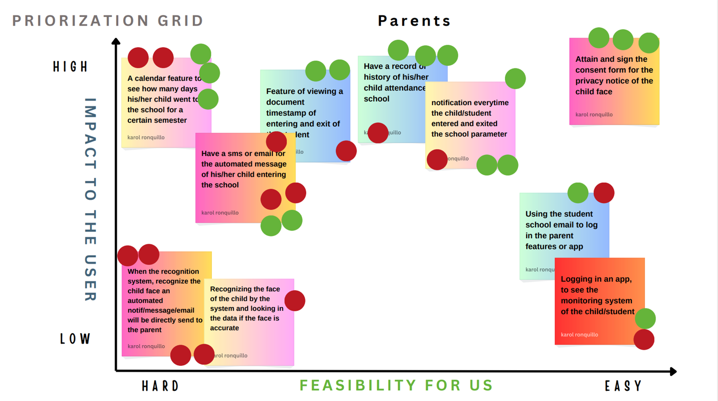

Figure 37: Prioritization Grid (Parents)

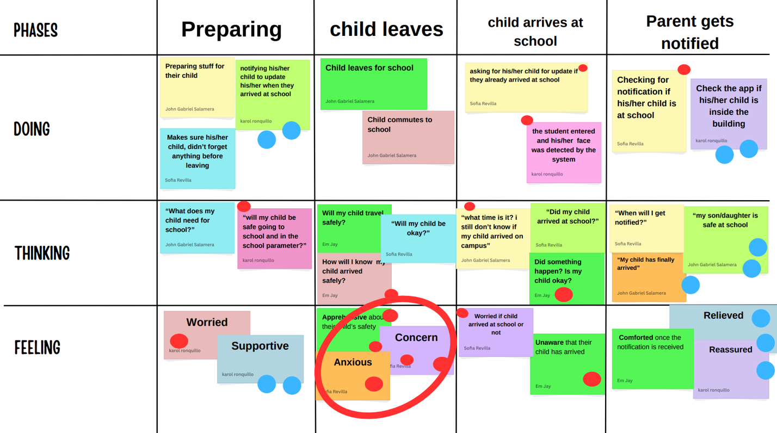

Figure 38: Scenario Map (Parents)

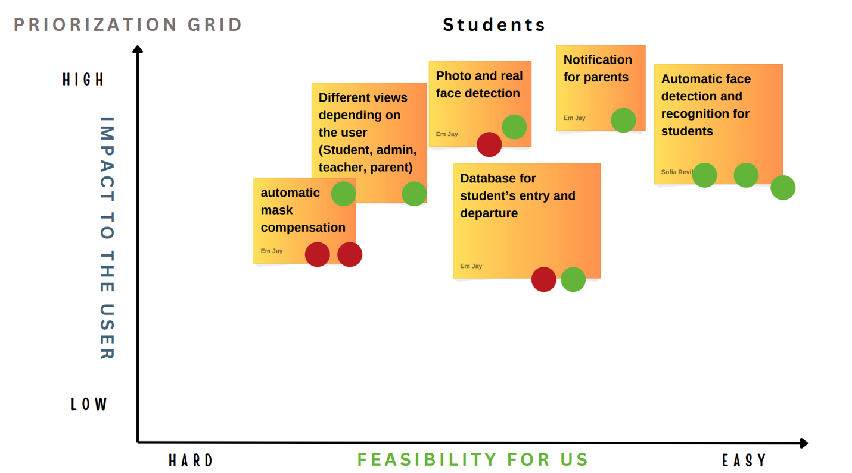

Figure 39: Priotization Grid (Students)

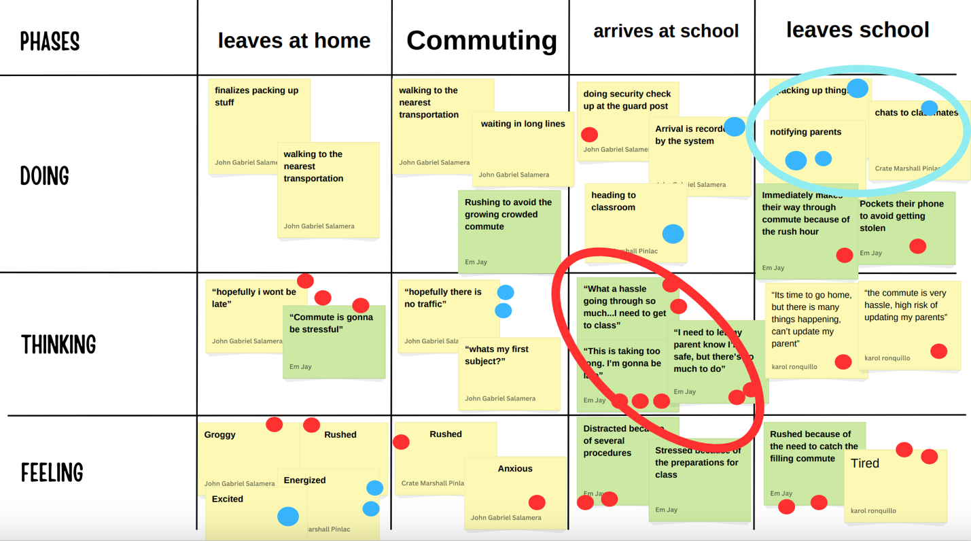

Figure 40: Scenario Map (Students)

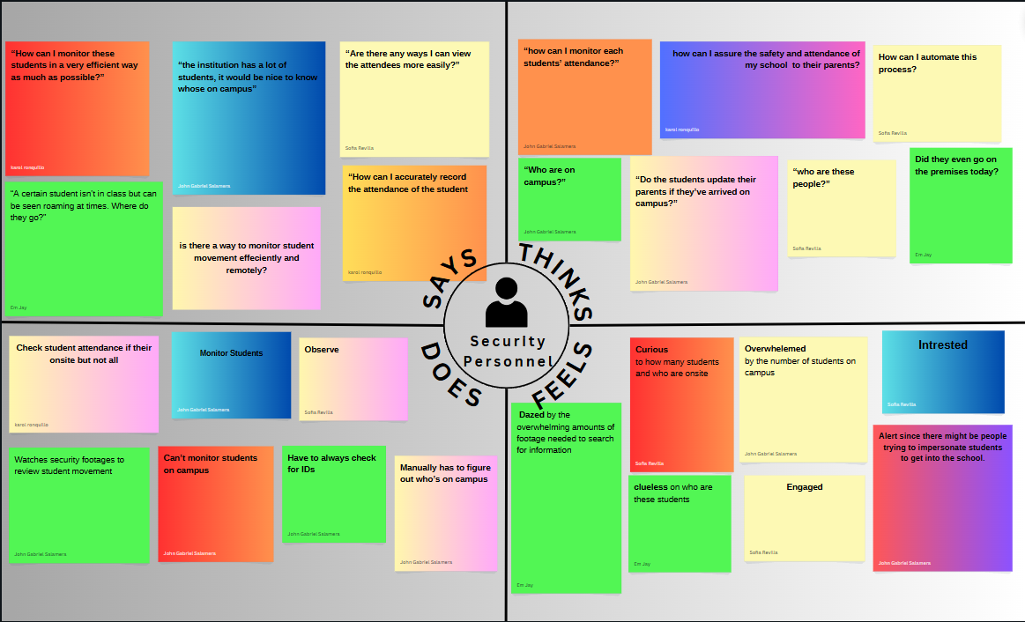

Figure 41: Empathy Map (Security Personnel)

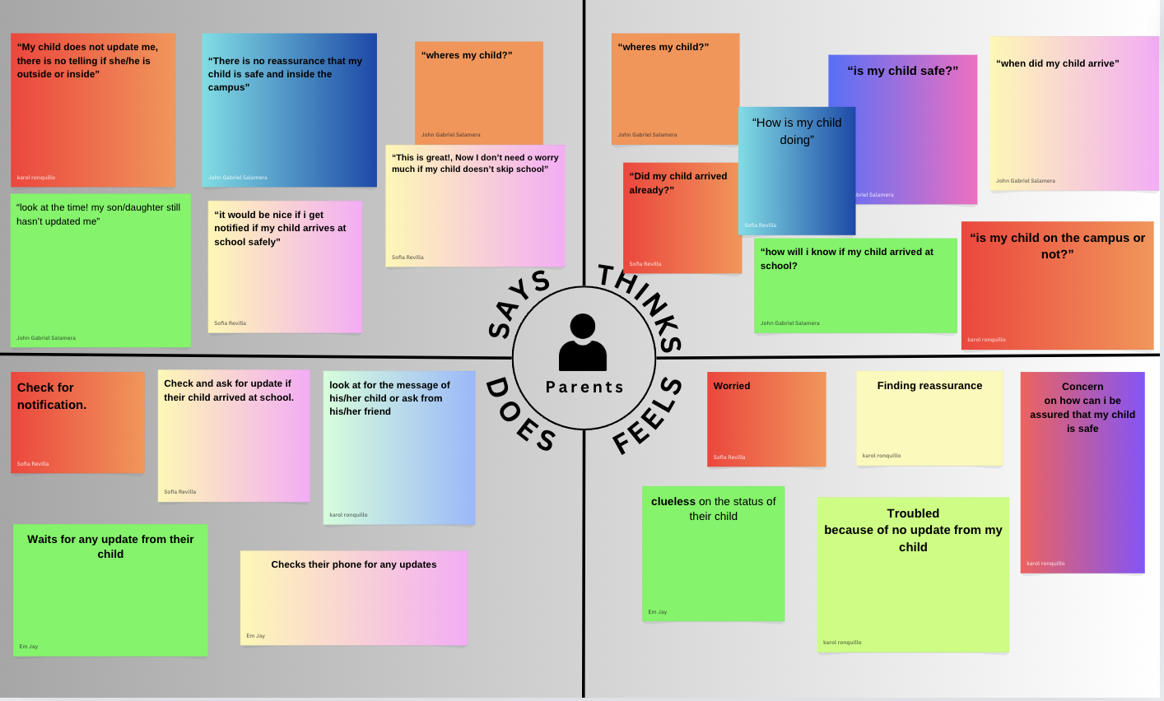

Figure 42: Empathy Map (Parents)

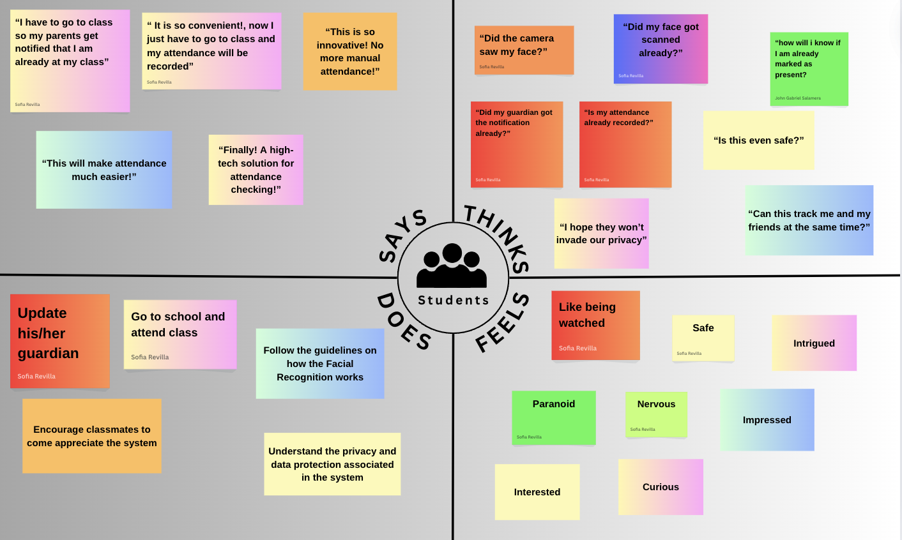

Figure 43: Empathy Map (Students)

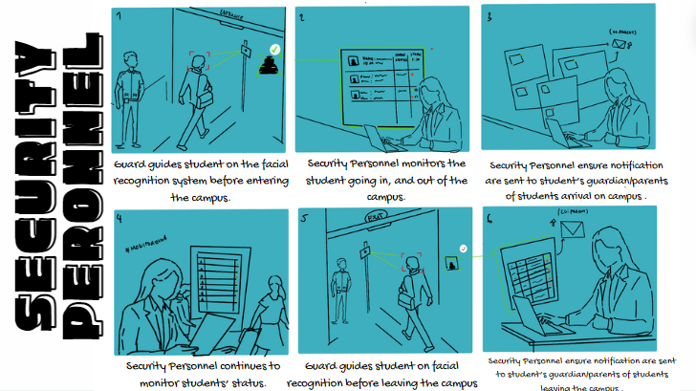

Figure 44: Storyboard (Security Personnel)

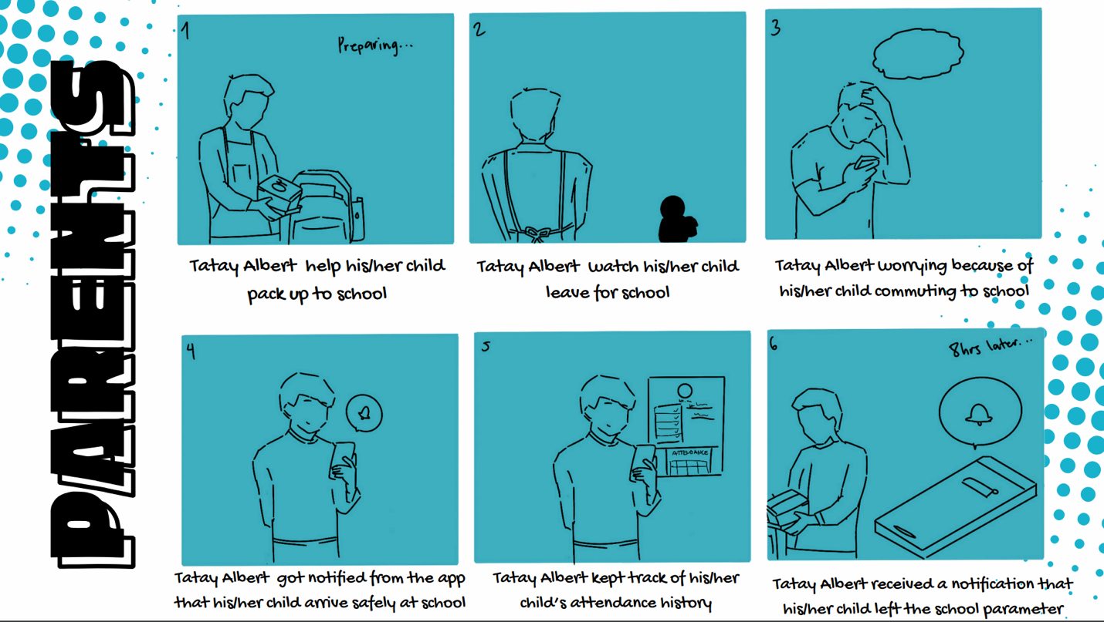

Figure 45: Storyboard (Parents)

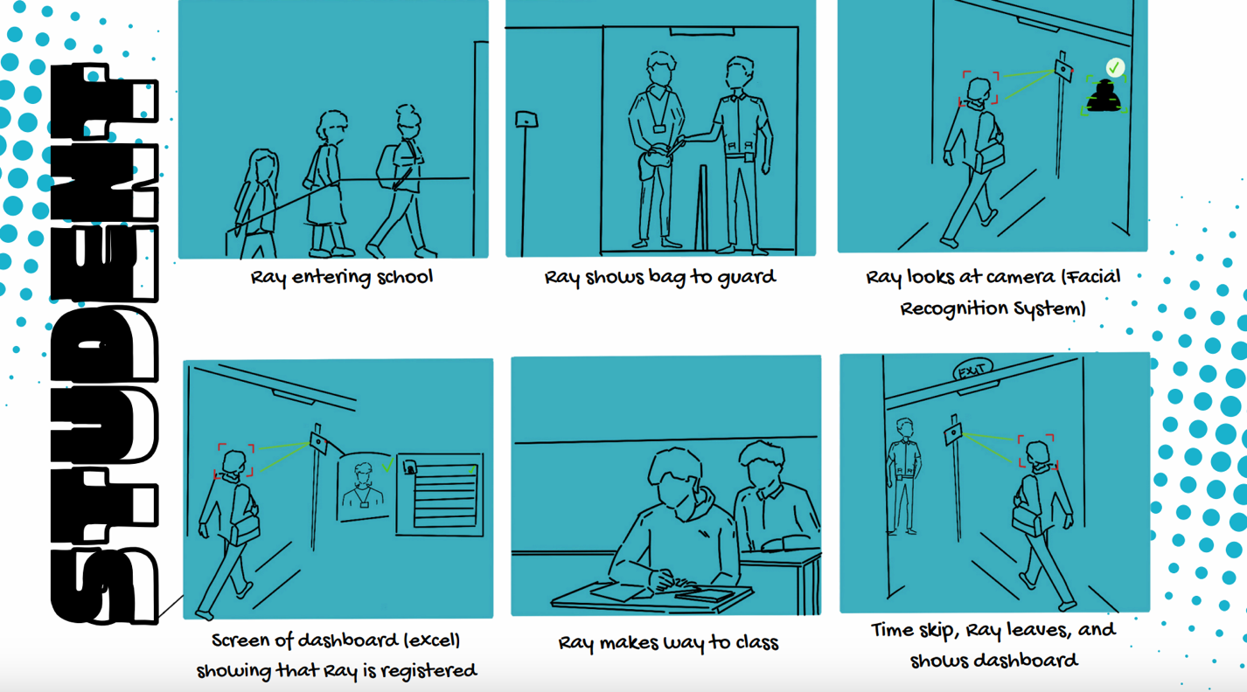

Figure 46: Storyboard (Student)

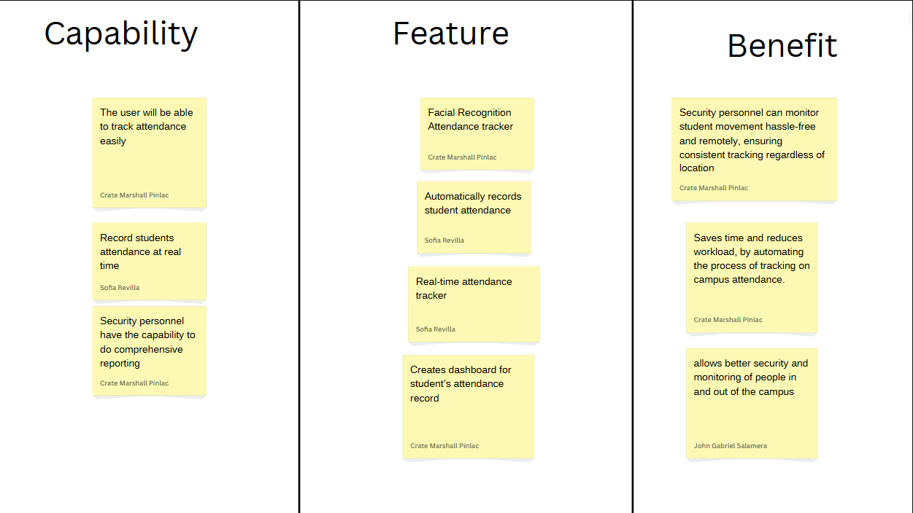

(a) EBR of Security personnel (capability, feature and benefit)

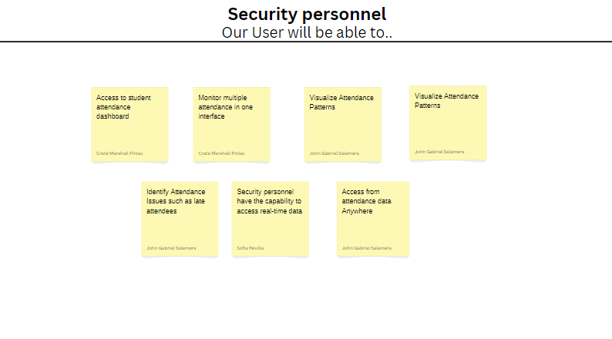

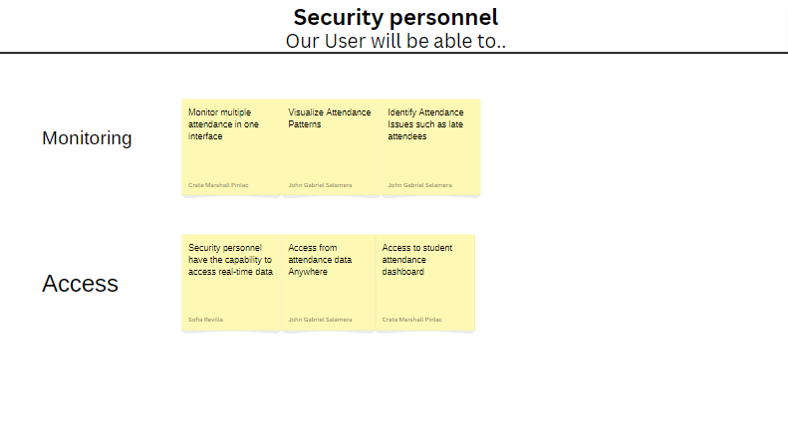

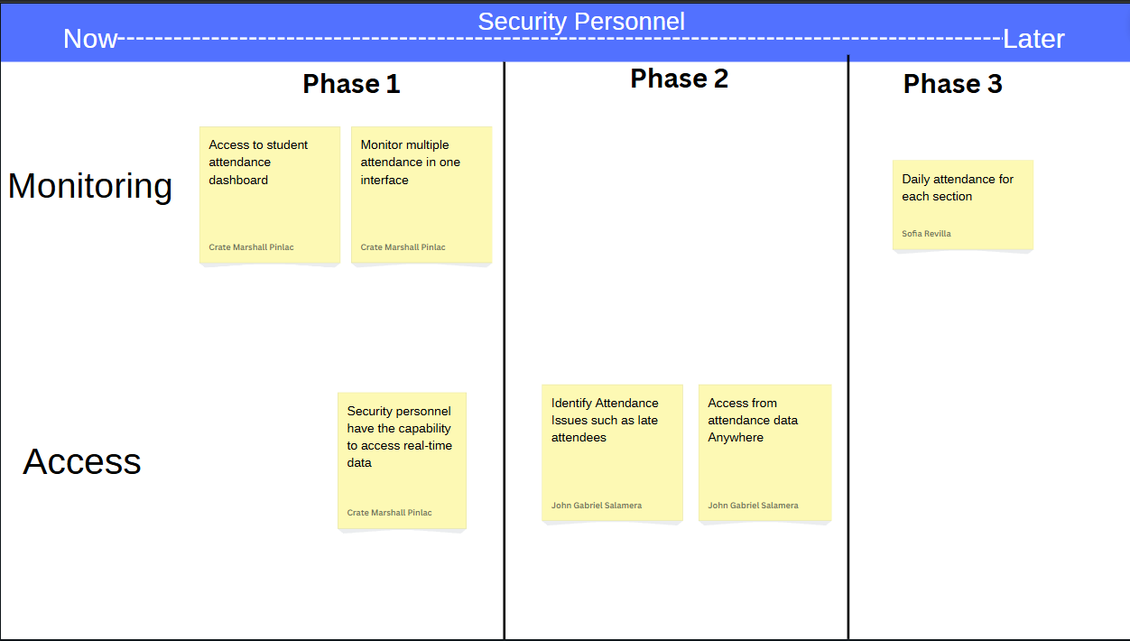

Figure 47: ERB of Security Personnel

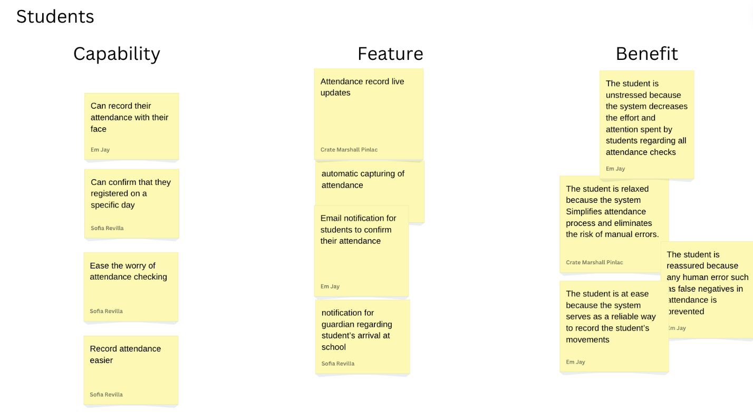

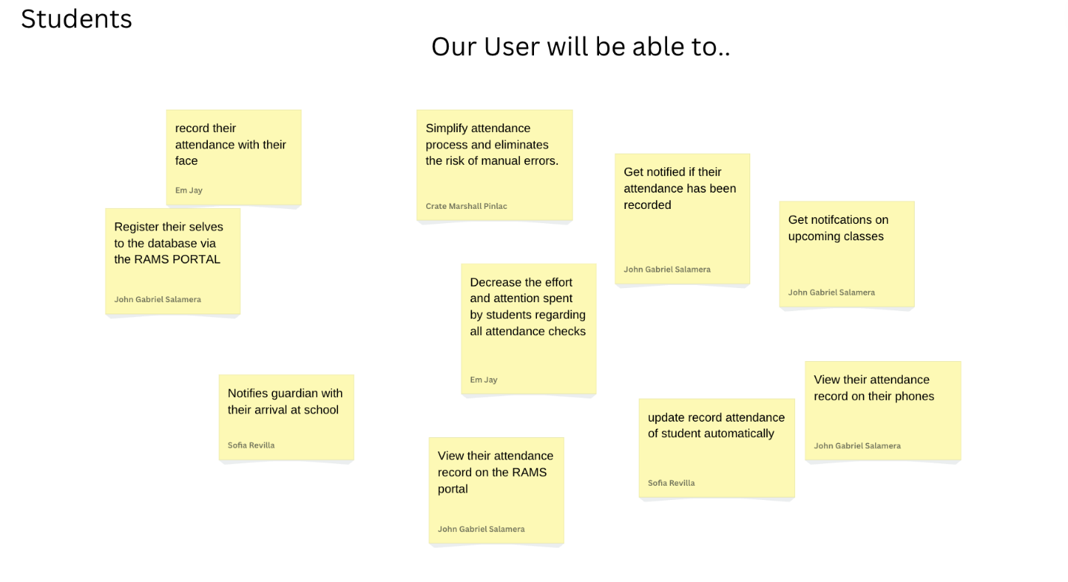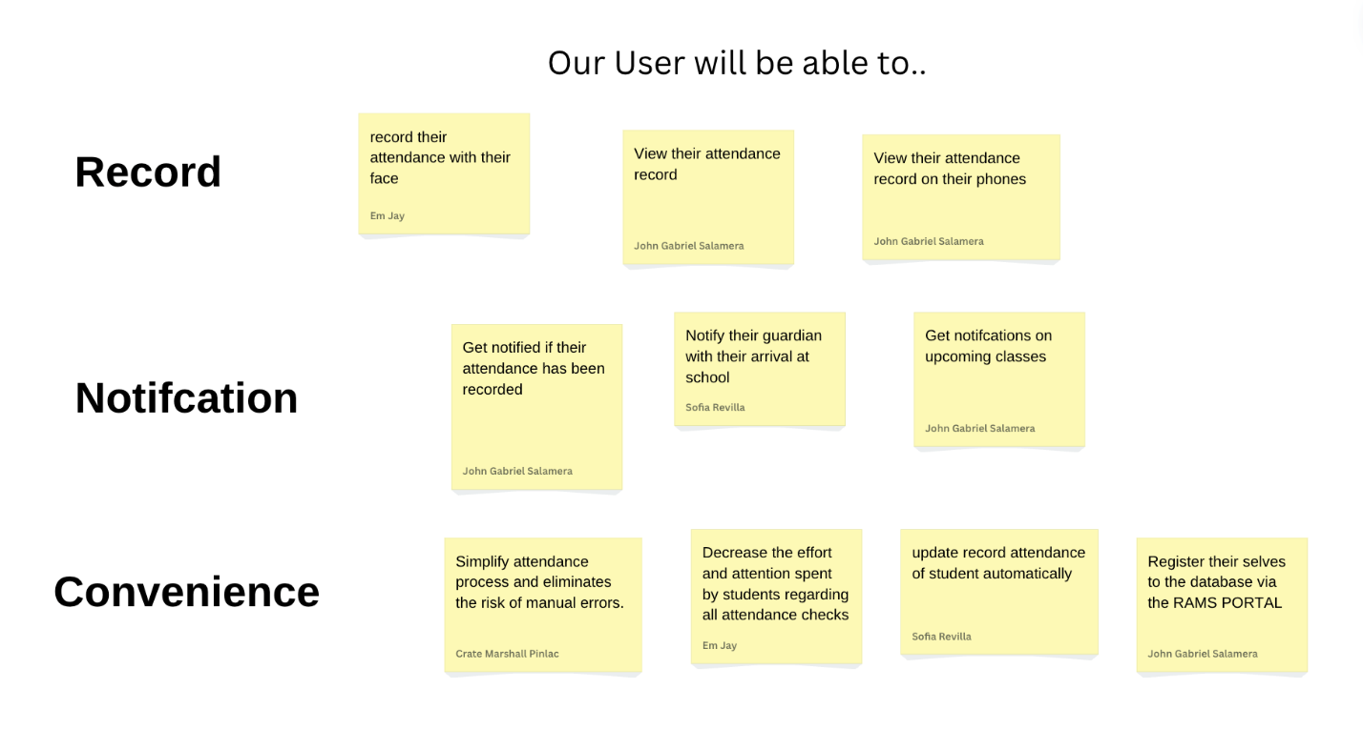

Figure 48: ERB of Students

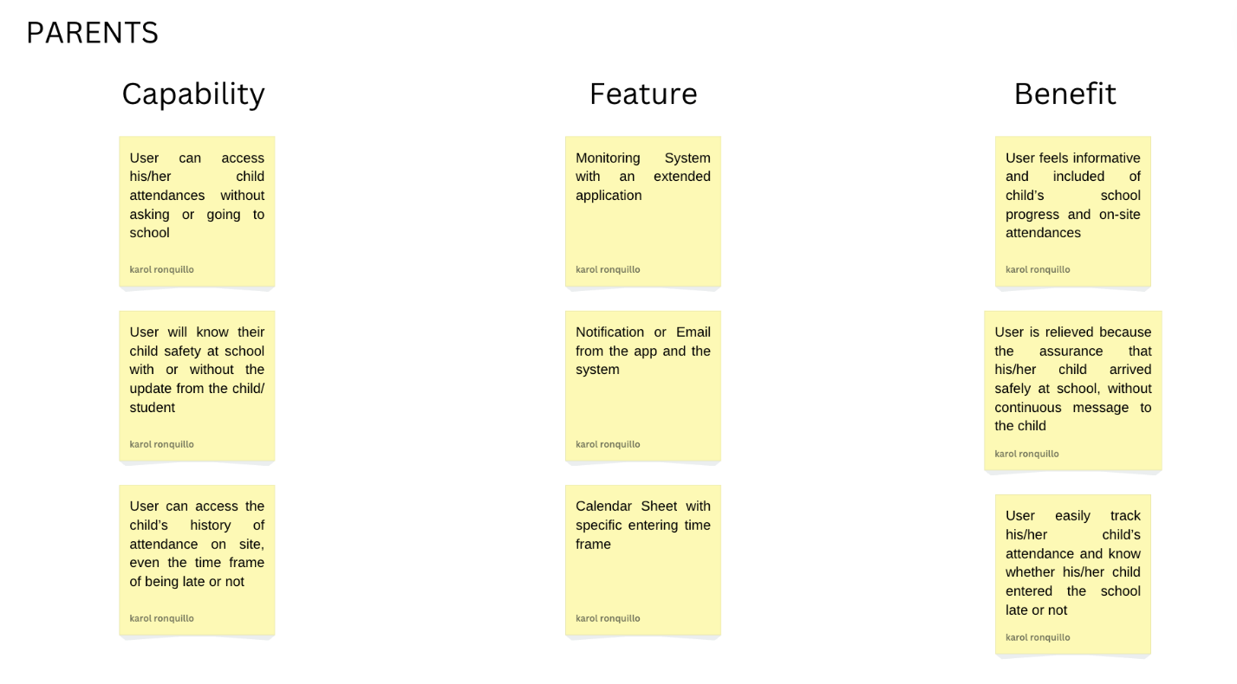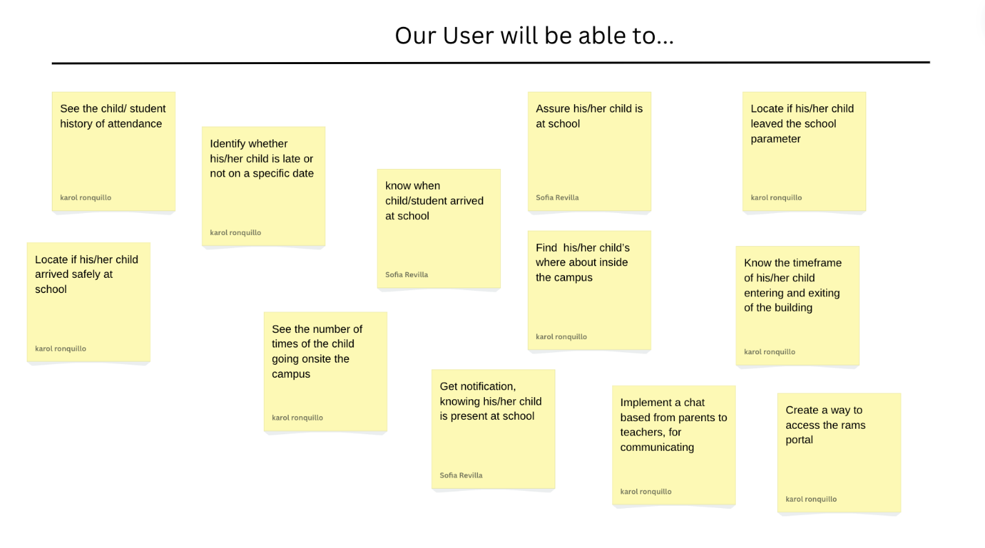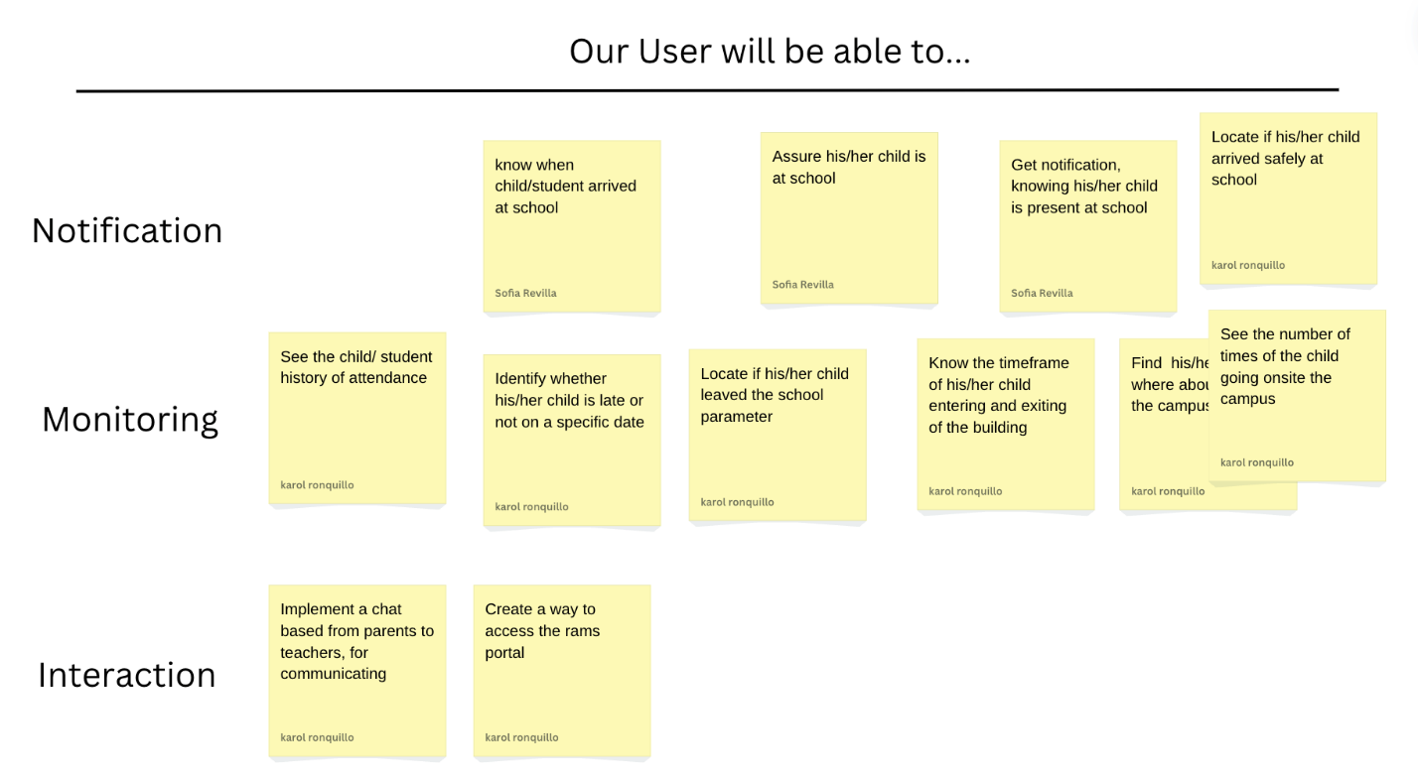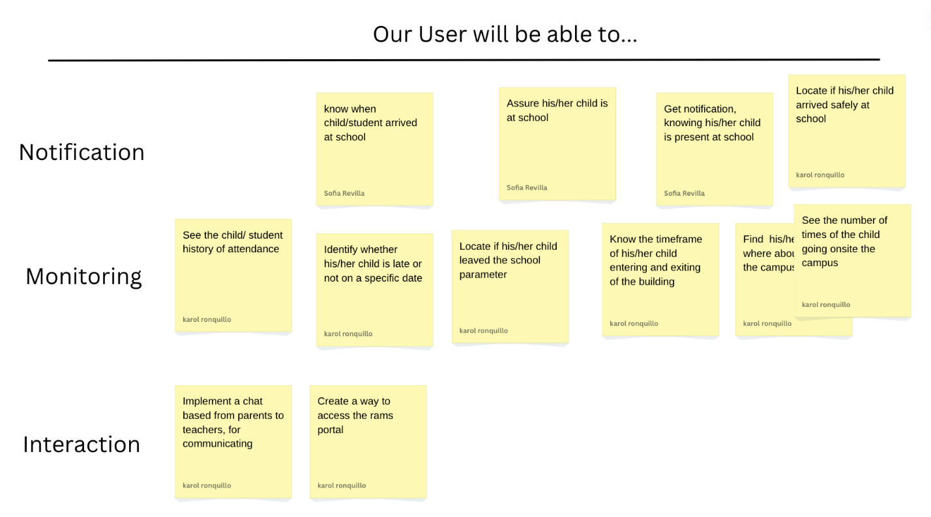

Figure 49: ERB of Parents

**Appendix J : Group Contribution**

|  |  |
| --- | --- |
| **Name** | **Contribution** |
| ARAGON, MJ | Back End, Front end, Design Thinking, Prototyping and UI design, Documentation |
| PINLAC, CRATE MARSHALL | Front end, Design Thinking, Prototyping and UI design, Documentation |
| REVILLA, MA. SOFIA ANNE | Front end, Design Thinking, Prototyping and UI design, Documentation |
| RONQUILLO, KAROL JOY | Front end, Design Thinking, Prototyping and UI design, Documentation |
| SALAMERA, JOHN GABRIEL | Back End, Front End, Design Thinking, Prototyping and UI design, Documentation |